Sustaina trip: A Climate-Friendly Trip Itinerary Generator

(Major Project)
Submitted in partial fulfillment of the requirements for the award of the degree of
Bachelor of Computer Application Batch:2022-25
AcademicSession:2024-25(Even)


Submitted to: Submitted by:
Dr.Sushma Bahuguna Siddharth Popli 35121302022
Shift: Evening Year/Sem:3rd/6th

Department of Information Communication & Technology


SELF CERTIFICATTE

This is to certify that the project report entitled “SustainaTrip: A Climate-Friendly Trip Itinerary Generator” is done by me and is an authentic work carried out for the partial fulfillment of the requirements for the award of the degree of Bachelor of Computer Applications under the guidance of Dr Sushma Bahuguna. The matter embodied in this project work has not been submitted earlier for the award of any degree or diploma to the best of my knowledge and belief.

Signature of the student
Siddharth Popli
35121302022

ACKNOWLEDGEMENT

I express my sincere gratitude to Dr. Sushma Bahuguna and for their valuable guidance and timely suggestions during the entire duration of my major project work, without which this work would not have been possible. I would also like to convey my deep regards to all other faculty members who have best owed their great effort and guidance at appropriate times without which it would have been very difficult on my part to finish this work. Finally I would also like to thank my friends for their advice and for pointing out my mistakes.

Signature of the student
Siddharth Popli
35121302022

CERTIFICATE FROM THE GUIDE

This is to certify that this project entitled “SustainaTrip: A Climate-Friendly Trip Itinerary Generator”, submitted in partial fulfillment of the degree of Bachelor of Computer Applications to the GURU GOBIND SINGH INDRAPRASTHA UNIVERSITY through the ICT Department, done by Siddharth Popli, Roll No. 35121302022, is an authentic work carried out by him at Tecnia Institute of Advanced Studies under my guidance. The matter embodied in this project work has not been submitted earlier for the award of any degree or diploma to the best of my knowledge and belief.

Signature of the student Signature of the Guide

ABSTRACT
This project presents the development of a Smart Waste Segregation and Reuse System, a technology-driven web-based application aimed at promoting efficient waste management and sustainable reuse practices. The system is designed to automatically identify, segregate, and categorize waste based on material type, while offering reuse suggestions to users based on common household and industrial waste items. The primary goal is to foster environmental responsibility and reduce the volume of waste sent to landfills.
Built using modern web technologies such as HTML, CSS, JavaScript, and Python (Flask), the application combines hardware components (sensors and microcontrollers) with a user-friendly dashboard. It collects waste input data using sensors and intelligently classifies it into categories such as biodegradable, non-biodegradable, recyclable, and hazardous. A web interface allows users to monitor segregation statistics and explore eco-friendly reuse strategies.
By integrating real-time data, environmental standards, and smart classification methods, this system raises awareness, supports recycling initiatives, and encourages mindful disposal and reuse. This project demonstrates how smart systems can transform traditional waste management into a sustainable, intelligent, and participatory process.

SYNOPSIS
Title: Smart Waste Segregation and Reuse System

1. Introduction
The Smart Waste Segregation and Reuse System is a smart solution designed to automate the process of waste segregation and promote sustainable reuse practices. It leverages sensor-based hardware to identify the type of waste and a responsive web dashboard to display results, suggest reuse tips, and educate users.
The system uses embedded electronics and cloud-connected software to evaluate waste properties such as material, moisture, and metal content. Based on these parameters, it sorts waste into appropriate bins and provides eco-conscious reuse ideas. The system’s ultimate goal is to reduce environmental harm, support circular economy practices, and empower communities with sustainable waste handling knowledge.

2. Problem Definition
Improper waste disposal and lack of segregation at the source contribute significantly to pollution, greenhouse gas emissions, and landfill overflows. Manual sorting is time-consuming, unsanitary, and error-prone. Additionally, users often lack awareness of how everyday items can be reused or repurposed effectively.
Current waste management systems focus mainly on collection and disposal, with limited attention to intelligent segregation or public education. The absence of integrated digital and hardware tools for real-time sorting, tracking, and suggestion-based reuse creates a major gap in sustainable waste practices.
This project proposes a Smart Waste Segregation and Reuse System that bridges this gap. It utilizes sensors for detection, a microcontroller for classification, and a web-based interface for monitoring and public engagement. The system promotes zero-waste goals and encourages reuse through an educational and data-driven approach.

Objectives
- To design a smart system capable of classifying waste into biodegradable, non-biodegradable, recyclable, and hazardous types using sensor data.
- To provide real-time segregation data and analytics via a web dashboard.
- To suggest creative and practical reuse ideas based on common waste types (e.g., plastic, glass, paper).
- To reduce health hazards associated with manual waste handling.
- To raise awareness about the environmental impact of improper waste disposal and the benefits of reuse and recycling.

3. Literature Review
With the global rise in waste generation, sustainable waste management is increasingly critical. Several studies and tools emphasize the need for smarter segregation and public participation.
Key findings:
- Sensor-Based Waste Identification: Research highlights the effectiveness of IR, metal, and moisture sensors in classifying waste with high accuracy.
- Automation Reduces Risk: Automated segregation reduces human contact with hazardous materials and speeds up sorting.
- Reuse Education: Studies stress the importance of incorporating user-facing reuse guides to increase recycling participation.
- Data-Driven Waste Management: Platforms with historical waste data and analytics improve municipal planning and environmental monitoring.
- Integration with Web Technologies: Combining hardware with responsive web dashboards enhances usability and user engagement, especially in community and institutional settings.

4. Methodology
The Prototype Model will be followed to design, test, and deploy the system. This iterative method ensures continual improvement based on user feedback and hardware behavior.
Requirement Gathering
- Survey users (households, schools, businesses) about common waste types and reuse habits.
- Study existing waste management systems and identify their limitations in segregation and awareness.
System Design
- Hardware: Use IR sensors, moisture sensors, and metal detectors for classification.
- Microcontroller: Arduino/Raspberry Pi to collect sensor data and control sorting mechanisms.
- Software:
  - Backend: Flask or FastAPI (Python)
  - Frontend: HTML, CSS, JavaScript
  - Dashboard: Displays bin status, statistics, and reuse suggestions
Development
- Connect sensors to microcontroller for real-time waste input detection.
- Write Python logic to determine waste category and trigger physical sorting.
- Build a responsive web interface for data visualization and user interaction.
Testing
- Test segregation accuracy with various waste samples.
- Perform user testing on the dashboard for ease of access, clarity of suggestions, and responsiveness.
- Validate data logging and tracking features.
Deployment
- Deploy the web dashboard using Vercel or AWS.
- Integrate with cloud database (CSV or MongoDB) to store waste statistics and user logs.
- Enable optional features like user accounts, suggestion history, and mobile access.

Tools
- Microcontroller: Arduino Uno or Raspberry Pi
- Sensors: IR sensor, moisture sensor, metal detector
- Backend: Python (Flask/FastAPI)
- Frontend: HTML, CSS, JavaScript
- Database: CSV or MongoDB
- Visualization: Chart.js or Plotly for displaying waste types, bin levels, and reuse stats
- Hosting: Vercel, Heroku, or AWS

Research Gap
Although several cities and institutions deploy waste bins for segregation, very few systems offer real-time sorting with reuse-focused recommendations. Most lack a data-driven approach and interactive dashboards to engage users in sustainability practices.
This project fills that gap by providing an automated, informative, and reusable system that combines the physical act of segregation with digital tools to encourage community-driven environmental responsibility.

References
- Central Pollution Control Board (CPCB) Guidelines – Solid Waste Management Rules 2016
- IEEE Papers on Smart Waste Bins and IoT-based Segregation Systems
- Arduino & Raspberry Pi Sensor Integration Manuals
- Ministry of Environment, Forest and Climate Change, India
- ResearchGate: Intelligent Waste Management Using Sensor-Based Systems
- National Geographic – Circular Economy Reports
- UNEP – Waste Management in Developing Countries
- RecycleNow – Reuse Tips and Waste Categories
- SmartBin.io – Case Studies in Sensor-based Waste Collection
- Chart.js & Plotly Documentation for Data Visualization

TABLE OF CONTENTS

S NO. | TOPICS | PAGENO.
I. | Self-Certificate | 2
II. | Acknowledgement | 3
III. | Certificate From the Guide | 4
IV. | Synopsis | 5
V. | Main Report  - Objective & Scope of the Project.  - Theoretical Background Definition of Problem.  - System Analysis & Design vis- a-vis User Requirements.  - System Planning(PERTChart).  - Methodology adopted, System Implementation & Details of Hardware & Software used System Maintenance &Evaluation.  - Detailed Life Cycle of the Project  - ERD, DFD  - Input and Output Screen Design  - Process involved  - Methodology used testing  - Test Report,Print out of the Report & Code Sheet | 10  10  12  14  16  17  20
VI. | Coding and Screenshots of the project | 73
VII. | Conclusion and Future Scope | 89
VIII. | References | 90

Main Report
Objective
The primary goals of this report are to:
- Develop and present SustainaTrip, a digital travel planning tool that assists users—such as solo travelers, families, and friend groups—in planning trips based on real-time weather, individual budgets, and travel preferences.
- Analyze and compare multiple travel destinations by assessing factors like seasonal climate, local attractions, travel costs, and suitability for different traveler types (e.g., solo, couple, family, or friends).
- Provide personalized travel recommendations including estimated trip costs, best travel periods, sustainable travel suggestions, and destination-specific insights.
- Educate users on sustainable tourism by promoting eco-friendly destinations and low-impact activities.
- Evaluate the impact of SustainaTrip on promoting awareness and adoption of sustainable travel through interactive data visualizations, user-friendly interface design, and intelligent decision-making support.

Scope
This report focuses on the following areas:
Trip Optimization Focus Areas:
- Weather Suitability: Recommending destinations based on weather forecasts and ideal climate periods.
- Budget Planning: Estimating total travel costs (transportation, lodging, and activities) to match user budgets.
- Travel Companionship: Offering suggestions tailored to travel type—solo, couple, family, or friends.
- Sustainable Options: Highlighting eco-conscious destinations, low-emission travel methods, and responsible tourism choices.
Geographical Focus:
- Although designed for global use, this report emphasizes deployment in India, considering regional climatic diversity, seasonal travel patterns, and rising interest in domestic and sustainable tourism.
Target Audience:
- Indian students, working professionals, families, and environmentally conscious travelers seeking budget-friendly and climate-smart travel solutions.
Technologies Used:
- Streamlit for the interactive web interface.
- Plotly for visualizing budget and weather data.
- OpenWeatherMap, Google Places, and other public APIs for real-time and historical data.
Limitations:
- Dependence on historical and forecasted weather data.
- Generalized cost estimations (no direct bookings).
- Current version does not support multi-city travel or detailed day-wise activity planning.
Future Enhancements:
- Real-time alerts, carbon footprint estimators, savings planners, group trip collaboration, and booking integrations.

Theoretical Background and Problem Definition
Theoretical Background
As global tourism grows, so do its negative impacts—such as carbon emissions, resource overuse, and overtourism. In India, the domestic travel boom has exposed gaps in travel planning due to unpredictable weather, variable costs, and limited access to sustainable options. Climate change further complicates seasonal predictability, making trip planning riskier.
Sustainable travel requires tools that balance cost, weather, preferences, and environmental responsibility. With advances in data visualization, APIs, and web technologies, there's an opportunity to provide smart platforms that support climate-conscious decision-making—even for non-expert users.
Problem Definition
Despite growing awareness of sustainable tourism, most travelers still face key challenges:
- No tools that match destinations with real-time, favorable weather.
- Lack of personalization based on travel budget or companion type.
- Low awareness of eco-friendly travel options.
- Overreliance on rigid travel websites with limited dynamic features.
- Absence of a unified platform that integrates all key travel variables.
SustainaTrip addresses these problems by offering a smart, user-friendly web app that:
- Takes input such as travel month, budget, companion type, and destination preference.
- Recommends destinations aligned with seasonal climate and sustainable travel data.
- Provides personalized insights including cost, weather suitability, and eco-scores.
- Empowers users to plan informed, responsible trips without complexity.

System Analysis and Design
SustainaTrip is designed around modular, interactive components to deliver real-time, personalized, and eco-conscious travel suggestions.
Key Design Elements:
- Modular Input Forms: Collect user input in a step-by-step format for travel month, budget, companion type, and preferences.
- Itinerary Recommendation Engine: Processes data using climate, cost, and sustainability algorithms to suggest optimal destinations.
- Weather Data Integration: Uses APIs to avoid poor-weather destinations (e.g., monsoon-prone spots in July).
- Personalized Suggestions: AI-assisted logic offers tailored recommendations for various user types and travel styles.
- Dynamic Visualizations: Utilizes Plotly/Streamlit to show charts for climate suitability, cost breakdown, and sustainability scores.
- Session Management: Maintains user input during the session for continuity.
- Navigation & Layout: Clean sidebar/menu navigation for switching between planning, itinerary view, and sustainability insights.
- Responsive Design: Works seamlessly across mobile, tablet, and desktop devices.

User Requirements Analysis
SustainaTrip caters to user needs with the following requirements:
- User-Friendly Interface: Designed for ease-of-use with minimal technical knowledge required.
- Personalized Matching: Suggests destinations and plans tailored to budget, weather, and travel companions.
- Climate-Smart Planning: Avoids poor weather periods and suggests best times to travel.
- Visual Presentation: Displays outputs (e.g., costs, weather ratings) using easy-to-understand visuals.
- Practical Itineraries: Includes trip length, activity suggestions, packing lists, and eco-tips.
- Future Scope – Progress Tracker: Potential dashboard for tracking past and future trips and sustainability impact.
- Educational Content: Includes responsible travel tips, eco-friendly practices, and government initiatives.
- Privacy and Security: User data is encrypted and handled securely.
- Device Compatibility: Works across multiple devices and platforms.
- Unit Flexibility: Supports both metric and imperial systems (e.g., INR vs USD, km vs miles).
- Tooltips and Help Guides: Contextual help to aid users in understanding input fields and outputs.

- System Planning (PERTChart)

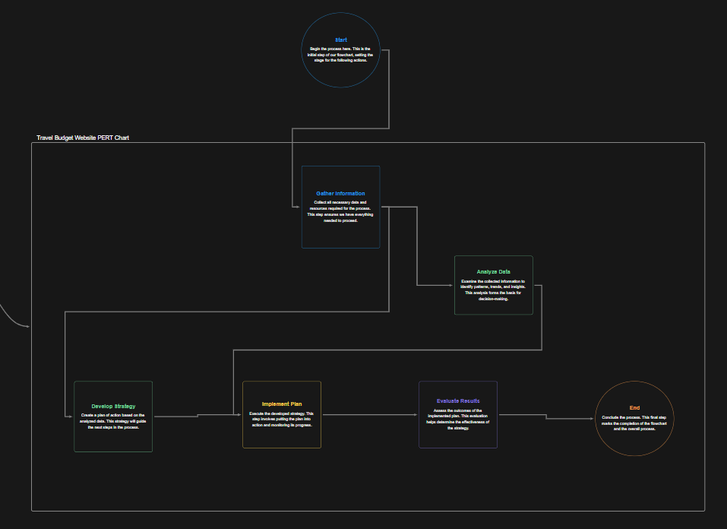

- ii) Methodology Adopted; System Implementation & Details of Hardware & Software Used; System Maintenance & Evaluation

- Methodology Adopted
- The development and assessment of the Smart Waste Segregation and Reuse System (SWSRS) followed a structured, problem-solving approach based on real-world waste management challenges, applying the following methodologies:
- Iterative Prototyping
- The SWSRS was developed through iterative prototyping, beginning with a basic prototype capable of detecting and classifying wet and dry waste using sensors. Successive iterations included features like object classification using image recognition, automatic sorting mechanisms, and logging of waste data for reuse analysis. Feedback from early testing phases guided hardware calibration and software optimization.
- User-Centered Design
- The system focused on ease of deployment in households, institutions, and small municipalities. User interaction was minimized and automation maximized — with a simple interface for monitoring and reporting waste segregation status. Safety, hygiene, and ease of maintenance were prioritized in both software and hardware design.
- Data-Driven Approach
- Sensor data (from cameras, IR sensors, moisture sensors, etc.) was processed in real-time to classify waste. Historical waste data was logged and analyzed to identify patterns for improving reuse suggestions or scheduling waste pickup. AI models and threshold logic refined over time enabled smarter segregation.
- Descriptive and Analytical Approach
- This report documents both system structure and logic, along with an analytical link between environmental impact goals and the system's functionality — from classification accuracy to waste reuse tracking.

- System Implementation & Details of Hardware and Software Used
- Software Used
- IDE: Visual Studio Code — for development and testing of embedded scripts and system dashboards.
- Embedded Programming: Arduino IDE / Python (MicroPython) — for sensor control and microcontroller interfacing.
- Object Detection (Optional/Advanced): TensorFlow Lite / OpenCV — for identifying plastic, paper, metal using image processing.
- Backend Framework: Flask (Python) — for managing data from the sensors and controlling logic of segregation and reuse recommendations.
- Dashboard/Interface: React.js (optional) — for real-time monitoring and reporting.
- Database: SQLite or Firebase — for logging categorized waste volumes and user interaction logs.
- Version Control: Git and GitHub — for tracking code versions and collaborative updates.
- Deployment Platform: Local server or cloud-based (AWS IoT or Azure IoT Hub) depending on scale.
- Hardware Used
- Microcontroller: Arduino Uno / ESP32 — for controlling sensors and actuators.
- Sensors:
- Moisture Sensor — to distinguish between wet and dry waste.
- IR/Ultrasonic Sensor — for object detection and motion sensing.
- Camera Module (e.g., Raspberry Pi Camera) — for object classification (optional).
- Actuators:
- Servo Motors — to open/close different bins based on classification.
- Conveyor Mechanism — to transport waste to correct bins.
- Other Components: Relays, power supply units, motor drivers, and sorting bins.
- Development Hardware: Standard laptop with 8 GB RAM and USB ports for programming and logging.
- Target Deployment: Household waste bins, office spaces, or public waste collection points.

- System Maintenance
- Sensor Calibration: Regular calibration of moisture and IR sensors for accuracy.
- Hardware Check: Routine inspection of motors, bins, and circuitry for physical wear or damage.
- Software Updates: Periodic updates for object classification models and backend logic.
- Waste Data Sync: Ensure consistent and secure upload of data to the cloud/database.
- Security Measures: Secure communication between microcontroller and database, especially in IoT deployments.
- Bug Tracking: Use GitHub Issues or manual logs to track hardware faults or software errors.
- User Support: Provide troubleshooting guides or web support for installations.

- System Evaluation
- Segregation Accuracy: Measure classification accuracy (correct bin assignment) against manually sorted benchmarks.
- Reuse Potential Assessment: Analyze logged data to evaluate the percentage of waste directed toward reuse or recycling.
- User Feedback: Gather insights from early adopters on ease of use, hygiene, and reliability.
- Operational Efficiency: Test system response time, sorting throughput, and average downtime.
- Environmental Impact Metrics: Estimate reduction in landfill waste or increase in recycled material volume.
- Performance Testing: Evaluate under high waste volume or in varied lighting/moisture conditions.
- Visualization Effectiveness: Ensure dashboard effectively conveys daily/weekly waste trends and actionable reuse suggestions.
- .

Detailed Life Cycle of the Project

  - ERD
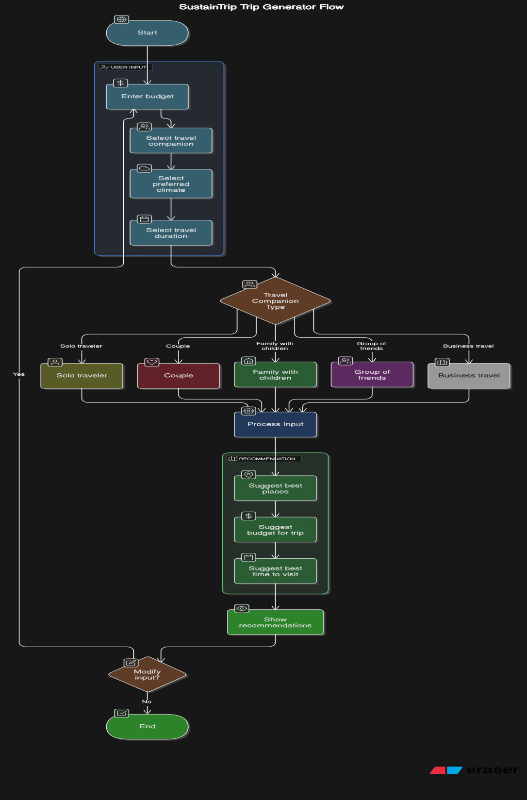

Detailed Explanation of the ERD:

This Entity-Relationship Diagram (ERD) models the database structure for a comprehensive carbon footprint tracking and management application. It aims to capture user activities, calculate their environmental impact, provide personalized guidance, and offer educational resources. The ERD consists of the following entities and relationships:

Start
- The process begins when the user launches the SustainaTrip app or web interface.

User Input Section
A set of required preferences is collected from the user to tailor the trip suggestions:
- Enter Budget
  - User provides how much they are willing to spend.
  - This helps the system filter destinations and accommodations that match the user’s financial plan.
- Select Travel Companion
  - Options include: Solo traveler, Couple, Family with children, Group of friends, or Business travel.
  - The recommendation algorithm adjusts accordingly (e.g., kids-friendly places for families).
- Select Preferred Climate
  - The user can choose preferred weather conditions like warm, cold, tropical, etc.
  - This helps in filtering destinations that match the ideal climate during the travel period.
- Select Travel Duration
  - Defines how long the user intends to stay (e.g., weekend, 5 days, 2 weeks).
  - Important for estimating budget and suggesting appropriately sized itineraries.

Travel Companion Type Decision Point
- Based on the user’s selected travel companion, the system branches into one of the following five categories:
  - Solo traveler
  - Couple
  - Family with children
Each type is processed differently to suit specific travel goals and experiences.
Process Input
Once all inputs are gathered, the system processes them through a rule-based or AI-driven engine. It considers:
- Climate-matched destinations
- Budget feasibility
- Ideal travel periods
- Companion-specific activity suitability

Recommendation Engine
This module generates trip suggestions based on processed inputs:
- Suggest Best Places
  - Lists top travel destinations suitable for the user’s profile (budget, climate, companion, duration).
- Suggest Budget for Trip
  - Provides an estimated cost breakdown (travel, stay, food, activities).
- Suggest Best Time to Visit
  - Recommends the most suitable months or weeks to visit based on historical climate and cost trends.
- Show Recommendations
  - Consolidates the above into a personalized, visually appealing itinerary or list.

Modify Input? (Decision Point)
- The user is asked if they want to change any input:
  - Yes: The flow loops back to the user input section.
  - No: The flow proceeds to the end.
  - End
- The trip planning process ends, and the user has a set of well-curated travel suggestions based on their preferences.

Benefits of This Flow
- User-friendly: Simple steps, clear decisions.
.

DFD

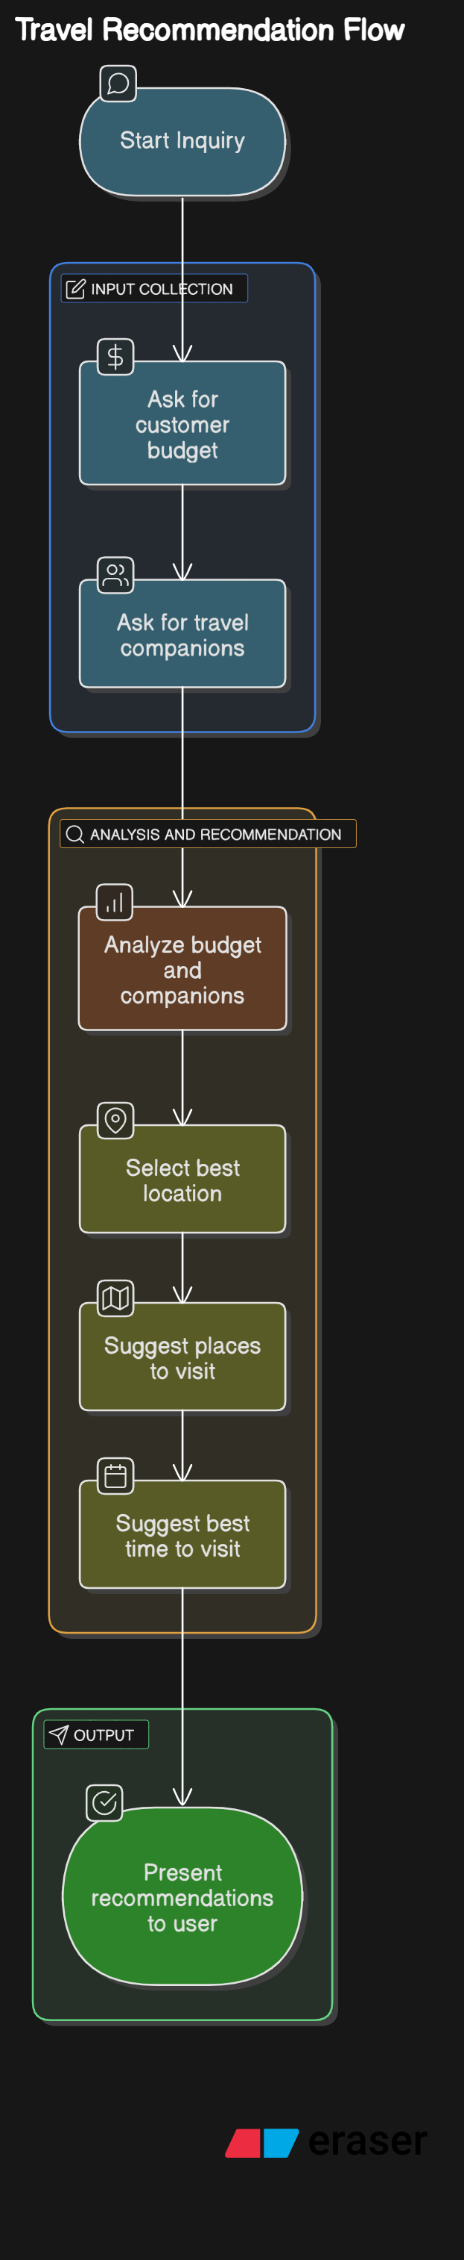
Overall System Purpose
The purpose of this system is to empower households and communities to implement effective waste segregation practices that align with their residential setup, local recycling infrastructure, and sustainability goals. The DFD (Data Flow Diagram) showcases how input data from users is processed through various logical layers to provide personalized, effective, and informed waste management recommendations. The flow facilitates the generation of waste segregation plans that help users minimize their environmental impact while maximizing resource recovery, convenience, and cost-effectiveness.
Start Inquiry
The system journey begins when a user initiates the inquiry—this can be triggered through a mobile app or website interface. It serves as the user's entry point into the WasteWise platform and sets the stage for personalized waste management planning.
Input Collection Phase
This module collects essential waste management preferences from the user, forming the foundation of the recommendation engine.
- Ask for Residential Setup
  - The system prompts the user to input their residential type (apartment, house, shared accommodation).
  - This value is essential to filter out waste management solutions that are either impractical or unsuitable.
  - Internally, the system maps the residential setup to available waste segregation options within a realistic range.
- Ask for Household Size
  - Users specify the number of household members: single, couple, family with kids, roommates.
  - This input helps in shaping container sizes, collection frequency, and storage-friendly segregation arrangements.
Analysis and Recommendation Phase
Once inputs are collected, the system processes this data using internal logic, possibly involving AI or heuristic algorithms.
- Analyze Residence and Household Size
  - Combines both inputs to assess compatibility with available waste management options.
  - For example, a small apartment with a family might trigger a search for space-efficient, multi-compartment solutions with child-safe features.
- Select Best Segregation Method
  - Based on the analysis, the system determines optimal waste segregation categories and containers.
  - Local recycling infrastructure, space constraints, and demographic-specific waste generation patterns are factored in.
- Suggest Materials to Segregate
  - Within the chosen method, the system identifies materials with high recycling value or environmental impact (e.g., plastics, paper, e-waste, organic waste).
  - Preference is given to locally recyclable materials and those with established collection systems.
- Suggest Best Containers and Practices
  - This ensures the waste segregation aligns with practical usage patterns (e.g., kitchen-friendly containers, odor-control for organic waste).
  - Avoids overly complex systems and leverages optimal container designs to improve adherence.
Output Phase
This phase presents the final recommendations to the user in an easy-to-understand format.
- Present Recommendations to User
  - A compiled waste management plan including the best segregation categories, container recommendations, suggested practices, and a potential cost summary is shown.
  - The output may include additional environmental insights (e.g., estimated waste reduction impact) and tips for reducing waste generation.
Intelligent System Design Features
- User-centric approach: Personalized results tailored to the user's living situation and household composition.
- Data-aware decision making: Waste management recommendations are not only user-suited but also environmentally conscious.
- Modular processing: Each phase handles a discrete function—making the system scalable and maintainable.
Conclusion
The Smart Waste Segregation Flow DFD for WasteWise demonstrates a streamlined yet robust system that leverages basic user inputs to deliver meaningful and eco-conscious waste management suggestions. The clean division between input, analysis, and output stages ensures clarity and operational efficiency. Furthermore, this system supports the global push toward sustainable waste management by promoting responsible waste segregation behavior through data-driven insights.
Process Involved in Project Development
1. Project Initiation and Planning
Project Conception and Justification: The concept behind WasteWise was created with the growing demand for effective waste segregation and recycling solutions. As the world moves towards circular economy principles, the waste management industry must also transition towards more efficient practices. The system aims to provide users with data-backed recommendations that align with the principles of sustainable waste management.
2. Requirements Gathering and Analysis
a) User Needs Assessment:
To ensure that WasteWise addresses the needs of its target audience, the following steps were involved:
- Identifying Target Users: The platform is targeted towards individuals, housing communities, and municipal bodies who are inclined towards improving waste segregation practices.
- User Expectations: Gathering feedback from users about their interest in effective waste management options, the level of personalization needed, and their preferred modes of data presentation.
- Key User Goals:
  - Find practical waste segregation solutions
  - Evaluate the environmental impact of different waste management options
  - Access personalized recommendations for waste containers and practices
b) Functional Requirements Analysis:
Based on the insights from users, WasteWise's functional requirements include:
- Waste Management Planning Tool: Users can input their residential setup, and the system will recommend optimal waste segregation methods, container types, and practices based on their sustainability and practicality.
- Real-time Recycling Data: Access to APIs that provide local recycling infrastructure information, waste generation statistics, and sustainability ratings.
- Data Visualization: Interactive charts and graphs to help users compare their options visually.
- Personalized Recommendations: Users receive personalized waste segregation plans with sustainability scores based on their preferences and household patterns.
c) Non-Functional Requirements:
- Usability: The system should be user-friendly, with a simple interface.
- Performance: Quick and efficient analysis, especially when retrieving data from external sources.
- Scalability: The platform should accommodate a growing user base, allowing for additional data sources and user-driven features.
- Security: Data security is a priority, especially with users' personal and location information.
d) Data Requirements Analysis:
For accurate recommendations, the system relies on data from sources like:
- Waste Management Databases: For real-time tracking of recyclable materials across different regions and municipalities.
- Sustainability Ratings: Data about eco-friendly container designs and segregation practices.
- Demographic Data: Understanding the waste generation patterns of different household sizes and compositions.
System Analysis and Design
The System Analysis and Design stage of the WasteWise project will focus on outlining the architecture, components, data flow, and user interface to create a seamless, effective waste segregation planning experience. Here's how we could structure the system:
1. System Architecture
WasteWise adopts a multi-tiered architecture to ensure scalability, maintainability, and modularity:
- Presentation Tier (Frontend):
  - Built using Next.js and Tailwind CSS, this layer provides the user interface, allowing users to input their residential details, view results, and access personalized waste segregation recommendations. It ensures a responsive, easy-to-navigate platform.
  - Key features:
    - Residence Input: Users can input residential details, either by selecting options or using an address-based interface.
    - Data Visualization: Real-time sustainability data like waste reduction impact and segregation options displayed through charts and graphs (using Recharts).
- Application Tier (Backend):
  - This tier handles business logic, data processing, and API endpoints. Developed using Node.js (with Express.js), it ensures user authentication, handles database interactions, and fetches waste management data.
  - Key features:
    - User Authentication (sign-up/login).
    - Processing sustainability data and integrating recommendations from the Machine Learning model.
    - Communicating with external data sources (local recycling infrastructure, waste statistics).
- Data Tier (Database):
  - MongoDB stores user data (preferences, household information, past segregation plans) and reference data like waste category statistics or sustainability ratings for different container types.
- Machine Learning Tier (ML API):
  - The ML API, housed in a separate Flask service, predicts sustainability scores for waste segregation plans based on real-time data.
  - Key features:
    - ML Model: Predicts sustainability scores based on data like waste reduction potential, recycling rates, and household compatibility.
    - Prediction API: Sends data from the backend and returns predictions to recommend the most effective waste segregation alternatives.
- External API Integration Tier:
  - This tier integrates third-party APIs that provide environmental data, such as local recycling infrastructure, waste collection schedules, and material recovery rates.
  - Key features:
    - Real-Time Data: Fetches live recycling infrastructure data from external providers (e.g., municipal databases, recycling facilities).
2. Component Design
WasteWise will consist of several key components:
- User Interface (UI) Components (Next.js/React):
  - Residence Input Module: Allows users to input their residential details (through selection options or a simple form).
  - Data Visualization Module (Recharts): Displays sustainability-related data, including waste reduction estimates, segregation options, and container recommendations in an easy-to-read chart or graph.
  - Recommendation Display Module: Clearly shows the most sustainable waste segregation options (e.g., category systems, container types).
  - User Authentication Module: Handles user registration, login, and profile management.
  - Dashboard: Provides users with a personalized overview of their saved plans, waste reduction progress, and sustainability scores.
- Backend API (Node.js/Express.js):
  - User Authentication API: Manages user sign-ups, logins, and session information.
  - Residence Management API: Allows users to save and retrieve their residential details and household-based data.
  - Recycling Infrastructure Data API: Fetches real-time and historical waste management data from external sources.
  - ML API Client: Sends data to the ML API for prediction and receives sustainability recommendations.
  - Data Storage Interface: Manages data stored in MongoDB, including user information, residential data, and sustainability scores.
- Machine Learning Model (Python/Flask):
  - Data Ingestion and Preprocessing Module: Prepares residential setup and household size data for analysis.
  - Prediction Model: Analyzes the data and predicts the optimal sustainable waste segregation options (categories, containers, practices).
  - API Endpoint: Exposes a RESTful interface for the backend to send data and receive predictions.
- Database (MongoDB):
  - User Data: Stores user account information, preferences, and saved residential settings.
  - Reference Data: Stores sustainability analyses, including waste reduction potential estimates and segregation recommendations.
3. Data Flow
The typical data flow within the WasteWise system will follow these steps:
- User Input: The user inputs their residential details (residence type, household size).
- Backend Interaction: The frontend sends the residence data to the backend API (Node.js).
- External Data Fetching: The backend uses the Recycling Infrastructure Data API to retrieve waste management data related to the user's location.
- Data Processing: The backend sends the data to the Machine Learning API for prediction on sustainable waste segregation options.
- Recommendation Generation: The ML API analyzes the data and generates recommendations based on sustainability scores.
- Result Delivery: The backend API sends the recommendations back to the frontend, where the user sees the suggestions, including waste categories, container types, and best practices.
- Data Storage: User residence data, preferences, and waste management plans are stored in the MongoDB database for future reference.
4. User Interface (UI) Design
The UI design focuses on creating an intuitive and accessible experience for users:
- Clear Navigation: Easy-to-use interface for navigation between residence input, results display, and user profile.
- Informative Visualizations: Interactive charts (via Recharts) will visualize the sustainability of different segregation methods, container types, and waste reduction potential in a clear format.
- Concise Recommendations: Sustainability recommendations will be clearly presented in an actionable, easy-to-understand format.
- Responsiveness: Ensures the application works seamlessly across different devices (desktops, tablets, smartphones).
- Accessibility: Adheres to accessibility guidelines to ensure the platform is inclusive of users with varying abilities.
Project Planning and Management
The Project Planning and Management phase of WasteWise will be focused on delivering a fully functional web application for optimizing waste segregation practices. The project encompasses frontend development, backend setup, integration of machine learning models for sustainability analysis, and connectivity with external recycling data APIs. The project will be broken down into clear phases, with a focus on timely delivery, risk management, and effective resource allocation.
1. Key Phases
The WasteWise development cycle will involve several key phases:
- Requirements Gathering and Design:
  - Collecting and defining the functional requirements for the system, including user preferences, sustainability goals, and essential features like waste reduction calculations, segregation options, and eco-friendly container suggestions.
  - Designing a system architecture to support the frontend, backend, and machine learning model integration.
- Frontend and Backend Development:
  - The frontend will be built using Next.js and Tailwind CSS, ensuring a responsive, user-friendly interface.
  - The backend will be built using Node.js, integrating MongoDB for data storage and handling user authentication and session management.
- Machine Learning Model Integration:
  - The project will integrate a Flask-based ML model for analyzing user data and providing sustainability recommendations.
- Testing and Deployment:
  - Thorough testing to ensure robustness and performance of the application.
  - Deployment to platforms such as Vercel for the frontend and a reliable cloud service for the backend and database.
- Project Monitoring and Reporting:
  - Regular updates through project management tools to track progress and keep the team on schedule.
2. Risk Management
- API Changes: There could be potential changes to external APIs (recycling infrastructure, waste management) that could affect data retrieval. A proactive approach will involve keeping these APIs modular and updating them as necessary.
- Model Accuracy: Ensuring that the machine learning model predicts reliable and useful recommendations for waste segregation is a key risk. Regular testing and model refinement will help address this.
- User Adoption and Usability: Ensuring the app is intuitive and user-friendly. Conducting user testing at early stages will mitigate usability issues.
3. Project Timeline and Milestones
- Phase 1: Requirements Gathering and Design (2 Weeks)
  - Finalize system architecture and design the database schema.
  - Set up project management tools (e.g., Jira, Trello) for task allocation and progress tracking.
- Phase 2: Backend Development (4 Weeks)
  - Implement the database structure and define the data models.
  - Develop APIs for user authentication, residence management, and integration with external recycling infrastructure APIs.
  - Connect the backend to the Flask-based ML model for generating sustainability recommendations.
- Phase 3: Frontend Development (5 Weeks)
  - Develop the UI using Next.js and Tailwind CSS.
  - Implement dynamic components, user input forms, data visualization with Recharts, and charts displaying sustainability information.
  - Conduct regular UI testing across browsers and devices.
- Phase 4: Integration and Testing (3 Weeks)
  - Integrate the frontend with the backend.
  - Conduct integration testing to ensure data flows correctly between the backend, ML API, and frontend.
  - Perform load testing to ensure the platform can handle concurrent users.
- Phase 5: Deployment and Monitoring (2 Weeks)
  - Deploy the application to Vercel (frontend) and set up cloud services (backend).
  - Set up continuous monitoring for the backend and machine learning model to ensure ongoing performance.
4. Resource Allocation
- Development Team:
  - Frontend Developer(s): Focus on building the UI, implementing dynamic elements, and integrating with APIs.
  - Backend Developer(s): Build the server-side infrastructure, APIs, and integrate with external services.
  - Machine Learning Specialist: Design, train, and refine the sustainability prediction model.
  - QA Engineer: Conduct testing across all phases to ensure a bug-free, user-friendly application.
  - Project Manager: Oversee the development process, ensuring adherence to timelines and managing the risks.
- Tools and Technologies:
  - Frontend: Next.js, Tailwind CSS, Recharts for data visualization.
  - Backend: Node.js, Express.js, MongoDB.
  - Machine Learning: Flask, Python for model deployment.
  - Project Management: Jira, Trello.
  - Version Control: GitHub or GitLab for source code management.
5. Key Performance Indicators (KPIs)
- Development Milestones: Completion of backend APIs, frontend UI, and integration with the machine learning model.
- User Experience: User feedback and UI test results, focusing on ease of use and intuitive navigation.
- System Performance: Load testing results, server uptime, and API response times.
- Sustainability Impact: Accuracy of the sustainability recommendations provided by the machine learning model.
6. System Development and Implementation
Backend Development:
- Database Design: MongoDB will store user profiles, residence data, and sustainability metrics.
  - Data models include Users, Residences, WasteData, ContainerTypes, and Recommendations.
- API Development:
  - RESTful APIs for user authentication, residence management, and data fetching from external sources (recycling infrastructure, waste statistics).
  - API integration with the Flask ML model for receiving recommendations.
- External Integration:
  - Real-time recycling infrastructure and waste management data fetched via municipal APIs or waste management databases.
Frontend Development:
- HTML Structure: Define the layout and content elements (forms, charts, and navigation).
- CSS Styling: Using Tailwind CSS for efficient and responsive design.
- JavaScript Development: Handling user interactions, updating UI dynamically based on data, and managing application state with Next.js.
- Integration with Recharts for displaying sustainability data and waste reduction calculations.
Testing and Quality Assurance
It ensures that the application meets the defined requirements, functions reliably, and provides a high-quality user experience. Rigorous testing at various levels was conducted to identify and rectify defects before deployment.
Unit Testing
Individual components and modules of both the backend (Node.js APIs, data processing functions) and the frontend (Next.js components, utility functions) were tested in isolation. This involved writing specific test cases to verify the correctness of each unit's logic, ensuring that they performed their intended tasks accurately and handled various input scenarios appropriately. For the backend, this included testing API endpoints for correct data handling and response. For the frontend, it involved testing the behavior of individual UI components and their interactions.
Integration Testing
The interactions between different components and layers of the WasteWise system were thoroughly tested. This included verifying the seamless communication between the Next.js frontend and the Node.js backend APIs, the correct data exchange between the backend and the Flask Machine Learning API, and the proper interaction between the backend and the MongoDB database. Integration tests ensured that these distinct parts of the system worked together harmoniously to achieve the desired functionality, such as fetching recycling data, sending it for analysis, receiving recommendations, and displaying them to the user.
System Testing
The entire WasteWise application was tested as a cohesive system to ensure it met all functional and non-functional requirements. This involved simulating real-world user scenarios, such as a user inputting their residence type and household size, the system retrieving recycling infrastructure data, generating recommendations, and displaying the results. System testing verified end-to-end functionality, ensuring that all components worked together correctly to deliver the intended user experience and meet the overall project goals.
User Acceptance Testing (UAT)
While formal UAT with a large group might be a future step, internal testing with representative users or stakeholders was conducted to gather feedback on the application's usability, intuitiveness, and overall satisfaction. This helped identify any potential usability issues, areas for improvement in the user interface or workflow, and ensured that the application met the practical needs and expectations of its intended audience.
Performance Testing
The performance of the WasteWise application was evaluated to ensure its speed, responsiveness, and stability under anticipated user loads. This included testing page load times, API response times, and the system's ability to handle concurrent user requests without significant degradation in performance. Performance testing aimed to identify any bottlenecks and ensure a smooth and efficient user experience, even with a growing number of users.
Security Testing
Measures were taken to identify potential security vulnerabilities within the WasteWise application. This included assessing the security of user authentication mechanisms, data transmission between the frontend and backend, and the protection of sensitive user data stored in the MongoDB database. Basic security best practices were implemented to safeguard against unauthorized access and maintain the integrity of the application and user information.
Deployment and Release
The deployment of WasteWise involved publishing its distinct components to specialized hosting platforms. The Next.js frontend was deployed to Vercel, leveraging its optimized infrastructure for React-based applications. The Node.js backend API, responsible for core logic and data orchestration, was deployed to a platform like Heroku or AWS. Similarly, the Flask API serving the machine learning model was hosted on a platform suitable for Python web applications. The MongoDB database was set up and secured using a managed service.
DNS configuration ensured that the application was accessible via its designated web address. The initial release was carefully managed, potentially involving a phased rollout to monitor performance and gather early user feedback. Comprehensive monitoring and logging tools were implemented to track the application's health and identify any post-deployment issues.
A crucial aspect of the release process was the establishment of a rollback plan. This contingency ensured that in the event of critical errors after launch, the application could be quickly reverted to a stable, previous version, minimizing disruption for users. The successful deployment and release marked a significant milestone, making WasteWise available to empower users in making informed waste segregation decisions.
System Maintenance and Evolution
Maintenance and Support
Thorough Bug Fixing
- Systematic identification of software defects reported by users or discovered through proactive monitoring.
- Detailed investigation into the root cause of each bug to understand the underlying issue.
- Development and implementation of comprehensive solutions to effectively resolve the identified defects.
- Rigorous testing of fixes to ensure they do not introduce new issues and that the original problem is fully resolved.
Comprehensive Performance Monitoring
- Continuous tracking of key application performance indicators (KPIs) such as response times, CPU utilization, memory usage, and network latency.
- Proactive identification of performance bottlenecks, slowdowns, or areas of inefficiency within the system.
- Implementation of optimization strategies, including code refactoring, database tuning, and infrastructure adjustments, to enhance application speed and responsiveness.
Diligent Security Updates
- Regular monitoring for security patches and updates released by the underlying operating systems, frameworks (Next.js, Node.js, Flask), and libraries used in the application.
- Prompt application of these security updates to mitigate potential vulnerabilities and protect the application and user data from known threats.
- Periodic security audits and vulnerability scanning to proactively identify and address potential weaknesses in the system.
Effective Technical Support
- Providing timely and helpful assistance to users who encounter problems while using the application or have questions about its features and functionality.
- Troubleshooting user-reported issues through various channels (e.g., email, FAQs, potentially in-app support).
- Offering clear guidance and instructions to users on how to effectively utilize the application's features and resolve common issues.
Consistent System Administration
- Regular maintenance of the server infrastructure hosting the application, including software updates, configuration management, and resource allocation.
- Implementation of robust database backup strategies and regular execution of backups to prevent data loss.
- Effective management of application logs for monitoring system behavior, diagnosing issues, and identifying potential security threats.
System Evolution and Enhancement
Detailed Requirements Gathering
- Systematic collection of feedback from users through surveys, interviews, feedback forms, and analysis of usage patterns.
- Engagement with stakeholders to understand evolving business needs, new opportunities, and potential integrations.
- Thorough analysis of gathered feedback to identify valuable new features, desired improvements to existing functionality, and areas for enhanced user experience.
Structured Design and Development
- Careful design of new features and enhancements, considering user needs, system architecture, and technical feasibility.
- Adherence to coding standards and best practices to ensure maintainability and scalability of the codebase.
Managed Release Management
- Careful planning and coordination of the deployment of updated application versions containing new features or enhancements.
- Thorough testing in staging environments before releasing to production to minimize the risk of introducing new issues.
- Clear communication of the changes and new features to users through release notes, in-app announcements, or other appropriate channels.
Strategic Technology Upgrades
- Continuous evaluation of the underlying technologies used in the application to identify opportunities for improvement in performance, security, and maintainability.
- Planned upgrades to newer versions of frameworks (Next.js, Node.js, Flask), libraries, and the database system, ensuring compatibility and leveraging new features and security enhancements.
Thoughtful System Redesign
- Periodic review of the application's overall architecture and design to identify fundamental limitations or areas that could benefit from significant improvements in scalability, performance, or maintainability.
- Careful planning and execution of system redesign efforts, potentially involving significant modifications to the database schema, API architecture, or core components, to address evolving needs and ensure the long-term viability of the application.
Methodology Used for Testing
This involved a combination of different testing types and approaches throughout the development lifecycle. This platform plays a crucial role in helping users determine the most effective waste segregation methods based on residential data, ensuring quality, reliability, and user-friendliness is paramount. Testing not only validates the correctness of the application but also builds trust among users by providing them with a seamless and accurate experience.
The testing process for this project involves employing a combination of established testing methodologies. Each of these methodologies targets specific layers and functionalities of the application, identifying potential defects before they can affect the user.
Unit Testing
Purpose: Unit testing serves as the first line of defense against bugs and defects. It focuses on testing individual components, functions, methods, or classes in complete isolation from the rest of the system. The objective is to ensure that each unit of the code behaves exactly as expected under various conditions.
Description: In this methodology, each function or method is tested independently by providing controlled inputs and verifying the outputs against expected results. For the WasteWise application, unit testing would involve a detailed examination of the core functional modules such as:
- RecyclingDataAPIClient: Testing the logic that fetches and processes data from external recycling infrastructure APIs.
- MachineLearningAPIClient: Ensuring correct communication with the Flask ML API for sending data and receiving recommendations.
- DataProcessingFunctions: Verifying the accuracy of any data transformations or calculations performed on waste management data.
- FrontendComponentLogic: Testing the behavior and rendering of individual Next.js/React components.
Benefits:
- Early Detection of Defects: Bugs are cheaper and easier to fix when caught early at the unit level.
- Enhanced Code Quality: Writing unit tests encourages modular, reusable, and maintainable code.
- Increased Developer Confidence: A comprehensive unit test suite assures developers that existing features continue to work as expected after new changes.
Integration Testing
Purpose: While unit testing checks individual components, integration testing validates how these components work together. It is critical to ensure that modules exchange data properly and function seamlessly as an integrated system.
Description: In the context of the WasteWise application, integration testing involves combining unit-tested modules and testing the interfaces between them. Some integration test cases would include:
- Frontend Residence Input to Backend API: Ensuring that residence data entered by users is correctly passed to the backend.
- ML API Response to Backend Recommendation Logic: Verifying that recommendations received from the ML API are correctly processed and stored by the backend.
- Backend Data Retrieval for Frontend Display: Ensuring that relevant waste management data and recommendations are accurately retrieved from the backend and displayed on the user interface.
Approaches:
- Bottom-Up Testing: Begins with testing low-level modules and gradually integrates upward.
Benefits:
- Verifies Component Interaction: Confirms that modules communicate and collaborate effectively.
- Detects Interface Defects: Finds issues like data mismatches or incorrect API calls that may not be visible in isolated tests.
System Testing
Purpose: System testing provides an end-to-end evaluation of the application to ensure that the entire system functions in accordance with the defined specifications and requirements. It simulates real-world scenarios to validate both functional and non-functional aspects.
Description: At this stage, the entire WasteWise application is tested as a complete system in an environment that closely resembles production. System testing encompasses multiple layers, including:
- User Workflow Testing: Testing user scenarios such as inputting residence details, viewing the recommended waste segregation method, and observing the associated data visualizations.
- Basic Performance Testing: Checking the application's load times and responsiveness under typical usage.
- Basic Security Testing: Verifying the security of user authentication and data handling.
- Usability Testing (Informal): Ensuring that the user interface is intuitive and easy to navigate for the intended users.
Types of System Testing:
- Functional Testing: Checks whether all specified functions work correctly.
- Usability Testing: Ensures ease of use and user-friendliness.
- Performance Testing: Measures speed and responsiveness.
- Security Testing: Identifies basic vulnerabilities.
Benefits:
- Verifies Overall Requirements: Confirms that the application meets both functional and non-functional expectations.
- Detects System-Level Defects: Identifies issues that only emerge when the complete system is tested together.
- Ensures Release-Readiness: Builds confidence that the app is stable and ready for initial use.
User Acceptance Testing (UAT)
UAT is the final phase before the application's potential broader release. It ensures that the application not only works technically but also meets the real-world needs of the users it aims to serve. UAT acts as the ultimate validation of the product's fitness for purpose.
During UAT, a select group of representative users (internal stakeholders or simulated users in the initial phase) would test the WasteWise application under realistic conditions. They would interact with the platform as they would in their daily lives and report back on their experiences. Typical UAT activities include:
- Real-World Scenario Testing: Users input their actual residence details and evaluate the relevance and clarity of the recommendations.
- Feedback Collection: Users provide qualitative feedback on ease of use, clarity of the presented data, and the usefulness of the recommendations.
- Basic Defect Reporting: Any bugs or usability issues discovered during usage are reported for fixing.
Acceptance Criteria: UAT is guided by predefined acceptance criteria, which outline the specific conditions the application must meet to be deemed acceptable by the users. For example:
- The application should accurately identify waste segregation methods based on residence type and household size.
- Users should be able to easily understand the presented waste management data and recommendations.
- The application should load within an acceptable timeframe.
Benefits:
- Validates User Needs: Confirms that the website delivers value and aligns with user expectations.
- Identifies Usability Issues: Uncovers subtle UX/UI problems that developers or testers may have missed.
- Builds User Confidence: Encourages user buy-in by involving them in the final stages of product validation.

TestReport

The core objective of these efforts was to meticulously evaluate the application's overall quality, ensuring its reliability, accuracy in providing waste segregation recommendations, and intuitive user-friendliness. This detailed assessment aimed to confirm that SWRS (Smart Waste Recycling System) not only functions as intended but also meets the specific requirements outlined during the project's conception and analysis phases, ultimately delivering a valuable and trustworthy tool to its users. The testing strategy employed a multi-layered approach, encompassing a range of methodologies designed to scrutinize the application from its foundational units to its integrated system behavior and end-user experience.

At the base level, unit testing focused on validating the isolated functionality of individual components and modules within both the user-facing frontend, built with Next.js, and the server-side backend, developed using Node.js. This involved creating specific test cases to examine the logic of data fetching from external waste management APIs, the communication protocols with the Flask-powered Machine Learning API, the accuracy of waste classification algorithms, and the correct rendering and behavior of individual user interface components. The successful completion of unit tests provided a strong foundation, ensuring that the building blocks of the application operated as expected.

Moving up the testing pyramid, integration testing concentrated on examining the seamless interaction and data flow between these previously validated units. This critical phase involved testing the communication pathways between the frontend and the backend APIs, verifying the accurate transmission of waste data and the subsequent retrieval of analysis results and recycling recommendations. Furthermore, the integration testing process scrutinized the interaction between the backend and the external waste data providers, as well as the crucial exchange of information with the Machine Learning API responsible for generating the core waste segregation insights.

System testing then provided an end-to-end evaluation of the fully integrated SWRS application. This comprehensive testing phase simulated real-world user scenarios, such as a user inputting their waste item details and navigating the application to view the resulting waste segregation recommendations and supporting data visualizations. System testing assessed not only the functional correctness of the application's core features but also its basic performance characteristics under typical usage conditions, ensuring acceptable load times and responsiveness.

Finally, User Acceptance Testing (UAT), while potentially involving a limited group of internal stakeholders or simulated users during the initial stages of the project, served as the ultimate validation of SWRS's fitness for its intended purpose. This phase involved these representative users interacting with the application in realistic scenarios, mirroring how they would typically use the platform to determine the optimal waste segregation solutions for their needs. The feedback gathered during UAT focused on the intuitiveness of the user interface, the clarity and understandability of the presented information, and the overall perceived value and usefulness of the application's recommendations.

c) Process Involved Process Involved in Project Development:

Project Initiation and Planning

Project Conception and Justification: The concept behind WasteSmart was created with the growing demand for efficient waste management solutions. As the world moves towards sustainability, waste management practices must also transition towards more effective segregation and reuse. The system aims to provide users with data-backed recommendations that align with the principles of circular economy and sustainable waste management.

Requirements Gathering and Analysis: a) User Needs Assessment: To ensure that WasteSmart addresses the needs of its target audience, the following steps were involved:

Identifying Target Users: The platform is targeted towards individuals, waste management agencies, and municipal authorities who are inclined towards sustainable waste practices.

User Expectations: Gathering feedback from users about their interest in efficient waste segregation options, the level of personalization needed, and their preferred modes of data presentation.

Key User Goals: o Find proper segregation methods for different waste types o Evaluate the recycling potential of different materials o Access personalized recommendations for waste reuse opportunities b) Functional Requirements Analysis: Based on the insights from users, WasteSmart's functional requirements include:

Waste Identification Tool: Users can input their waste items, and the system will recommend optimal segregation methods, recycling opportunities, and reuse possibilities.

Real-time Waste Data: Access to APIs that provide material composition data, recycling facility information, and sustainability ratings.

Data Visualization: Interactive charts and graphs to help users understand waste management metrics visually.

Personalized Recommendations: Users receive personalized waste management suggestions with sustainability scores based on their waste generation patterns. c) Non-Functional Requirements:

Usability: The system should be user-friendly, with a simple interface.

Performance: Quick and efficient analysis, especially when retrieving data from external sources.

Scalability: The platform should accommodate a growing user base, allowing for additional data sources and user-driven features.

Security: Data security is a priority, especially with users' personal and location information. d) Data Requirements Analysis: For accurate recommendations, the system relies on data from sources like:

Waste Classification Databases: For real-time identification of different waste types and materials.

Recycling Facility Information: Data about available recycling centers and their capabilities.

Material Composition Data: Understanding the environmental impact of different materials, especially when considering recycling options.

System Analysis and Design:

The System Analysis and Design stage of the WasteSmart project will focus on outlining the architecture, components, data flow, and user interface to create a seamless, efficient waste segregation and reuse experience. Here's how we could structure the system for WasteSmart:

System Architecture: WasteSmart adopts a multi-tiered architecture to ensure scalability, maintainability, and modularity:

Presentation Tier (Frontend): o Built using Next.js and Tailwind CSS, this layer provides the user interface, allowing users to input their waste items, view results, and access personalized segregation recommendations. It ensures a responsive, easy-to-navigate platform. o Key features: Waste Input: Users can input waste item details, either by typing or using an image recognition interface. Data Visualization: Real-time waste management data like recycling potential and material composition displayed through charts and graphs (using Recharts).

Application Tier (Backend): o This tier handles business logic, data processing, and API endpoints. Developed using Node.js (with Express.js), it ensures user authentication, handles database interactions, and fetches waste classification data. o Key features: User Authentication (sign-up/login). Processing waste data and integrating recommendations from the Machine Learning model. Communicating with external data sources (waste databases, recycling facility information).

Data Tier (Database): o MongoDB stores user data (preferences, waste history, past segregation patterns) and historical data like recycling statistics or sustainability ratings for materials.

Machine Learning Tier (ML API): o The ML API, housed in a separate Flask service, predicts waste classification and recycling potential based on real-time data. o Key features: ML Model: Predicts waste segregation recommendations based on data like material composition, recycling opportunities, and local facility availability. Prediction API: Sends data from the backend and returns predictions to recommend the most appropriate waste management approaches.

External API Integration Tier: o This tier integrates third-party APIs that provide waste management data, such as material databases, recycling facility information, and waste composition analysis. o Key features: Real-Time Data: Fetches live waste management data from external providers (e.g., waste classification databases, recycling facility directories).

Component Design: WasteSmart will consist of several key components:

User Interface (UI) Components (Next.js/React): o Waste Input Module: Allows users to input their waste items (through text input, image recognition, or a selection interface). o Data Visualization Module (Recharts): Displays waste management-related data, including recycling potential, material composition, and segregation options in an easy-to-read chart or graph. o Recommendation Display Module: Clearly shows the most appropriate waste segregation options (e.g., recycling methods, reuse opportunities). o User Authentication Module: Handles user registration, login, and profile management. o Dashboard: Provides users with a personalized overview of their waste management history, segregation patterns, and sustainability scores.

Backend API (Node.js/Express.js): o User Authentication API: Manages user sign-ups, logins, and session information. o Waste Management API: Allows users to save and retrieve their waste data and segregation history. o Material Classification API: Fetches real-time and historical waste classification data from external sources. o ML API Client: Sends data to the ML API for prediction and receives waste segregation recommendations. o Data Storage Interface: Manages data stored in MongoDB, including user information, waste data, and segregation recommendations.

Machine Learning Model (Python/Flask): o Data Ingestion and Preprocessing Module: Prepares real-time waste classification and material composition data for analysis. o Prediction Model: Analyzes the data and predicts the optimal waste segregation and reuse options. o API Endpoint: Exposes a RESTful interface for the backend to send data and receive predictions.

Database (MongoDB): o User Data: Stores user account information, preferences, and saved waste management patterns. o Historical Data: Stores past waste analysis, including previous segregation recommendations and recycling outcomes.

Data Flow: The typical data flow within the WasteSmart system will follow these steps:

User Input: The user inputs their waste item details (either by typing, selecting from options, or uploading an image).

Backend Interaction: The frontend sends the waste data to the backend API (Node.js).

External Data Fetching: The backend uses the Material Classification API to retrieve waste management data related to the user's item.

Data Processing: The backend sends the data to the Machine Learning API for prediction on waste segregation options.

Recommendation Generation: The ML API analyzes the data and generates recommendations based on material composition and recycling potential.

Result Delivery: The backend API sends the recommendations back to the frontend, where the user sees the suggestions, including recycling methods, reuse opportunities, and local facility options.

Data Storage: User waste data, preferences, and segregation patterns are stored in the MongoDB database for future reference.

User Interface (UI) Design: The UI design focuses on creating an intuitive and accessible experience for users:

Clear Navigation: Easy-to-use interface for navigation between waste input, results display, and user profile.

Informative Visualizations: Interactive charts (via Recharts) will visualize the recycling potential, material composition, and waste segregation options in a clear format.

Concise Recommendations: Waste management recommendations will be clearly presented in an actionable, easy-to-understand format.

Responsiveness: Ensures the application works seamlessly across different devices (desktops, tablets, smartphones).

Accessibility: Adheres to accessibility guidelines to ensure the platform is inclusive of users with varying abilities. Project Planning and Management:

The Project Planning and Management phase of WasteSmart will be focused on delivering a fully functional web application for optimizing waste segregation and reuse planning. The project encompasses frontend development, backend setup, integration of machine learning models for waste classification analysis, and connectivity with external material and recycling facility data APIs. The project will be broken down into clear phases, with a focus on timely delivery, risk management, and effective resource allocation.

Key Phases: The WasteSmart development cycle will involve several key phases:

Requirements Gathering and Design: o Collecting and defining the functional requirements for the system, including user preferences, waste management goals, and essential features like waste classification, recycling potential calculations, and reuse opportunity suggestions. o Designing a system architecture to support the frontend, backend, and machine learning model integration.

Frontend and Backend Development: o The frontend will be built using Next.js and Tailwind CSS, ensuring a responsive, user-friendly interface. o The backend will be built using Node.js, integrating MongoDB for data storage and handling user authentication and session management.

Machine Learning Model Integration: o The project will integrate a Flask-based ML model for analyzing waste data and providing segregation recommendations.

Testing and Deployment: o Thorough testing to ensure robustness and performance of the application. o Deployment to platforms such as Vercel for the frontend and a reliable cloud service for the backend and database.

Project Monitoring and Reporting: o Regular updates through project management tools to track progress and keep the team on schedule.

Risk Management:

API Changes: There could be potential changes to external APIs (waste classification, recycling facilities) that could affect data retrieval. A proactive approach will involve keeping these APIs modular and updating them as necessary.

Model Accuracy: Ensuring that the machine learning model predicts reliable and useful recommendations for waste segregation is a key risk. Regular testing and model refinement will help address this.

User Adoption and Usability: Ensuring the app is intuitive and user-friendly. Conducting user testing at early stages will mitigate usability issues.

Project Timeline and Milestones:

Phase 1: Requirements Gathering and Design (2 Weeks) o Finalize system architecture and design the database schema. o Set up project management tools (e.g., Jira, Trello) for task allocation and progress tracking.

Phase 2: Backend Development (4 Weeks) o Implement the database structure and define the data models. o Develop APIs for user authentication, waste management, and integration with external material classification APIs. o Connect the backend to the Flask-based ML model for generating waste segregation recommendations.

Phase 3: Frontend Development (5 Weeks) o Develop the UI using Next.js and Tailwind CSS. o Implement dynamic components, waste input forms, data visualization with Recharts, and charts displaying waste management information. o Conduct regular UI testing across browsers and devices.

Phase 4: Integration and Testing (3 Weeks) o Integrate the frontend with the backend. o Conduct integration testing to ensure data flows correctly between the backend, ML API, and frontend. o Perform load testing to ensure the platform can handle concurrent users.

Phase 5: Deployment and Monitoring (2 Weeks) o Deploy the application to Vercel (frontend) and set up cloud services (backend). o Set up continuous monitoring for the backend and machine learning model to ensure ongoing performance.

Resource Allocation:

Development Team: o Frontend Developer(s): Focus on building the UI, implementing dynamic elements, and integrating with APIs. o Backend Developer(s): Build the server-side infrastructure, APIs, and integrate with external services. o Machine Learning Specialist: Design, train, and refine the waste classification prediction model. o QA Engineer: Conduct testing across all phases to ensure a bug-free, user-friendly application. o Project Manager: Oversee the development process, ensuring adherence to timelines and managing the risks.

Tools and Technologies: o Frontend: Next.js, Tailwind CSS, Recharts for data visualization. o Backend: Node.js, Express.js, MongoDB. o Machine Learning: Flask, Python for model deployment. o Project Management: Jira, Trello. o Version Control: GitHub or GitLab for source code management.

Key Performance Indicators (KPIs):

Development Milestones: Completion of backend APIs, frontend UI, and integration with the machine learning model.

User Experience: User feedback and UI test results, focusing on ease of use and intuitive navigation.

System Performance: Load testing results, server uptime, and API response times.

Sustainability Impact: Accuracy of the waste segregation recommendations provided by the machine learning model.
The core objective of these efforts was to meticulously evaluate the application's overall quality, ensuring its reliability, accuracy in providing waste segregation recommendations, and intuitive user-friendliness. This detailed assessment aimed to confirm that SWRS (Smart Waste Recycling System) not only functions as intended but also meets the specific requirements outlined during the project's conception and analysis phases, ultimately delivering a valuable and trustworthy tool to its users. The testing strategy employed a multi-layered approach, encompassing a range of methodologies designed to scrutinize the application from its foundational units to its integrated system behavior and end-user experience.
At the base level, unit testing focused on validating the isolated functionality of individual components and modules within both the user-facing frontend, built with Next.js, and the server-side backend, developed using Node.js. This involved creating specific test cases to examine the logic of data fetching from external waste management APIs, the communication protocols with the Flask-powered Machine Learning API, the accuracy of waste classification algorithms, and the correct rendering and behavior of individual user interface components. The successful completion of unit tests provided a strong foundation, ensuring that the building blocks of the application operated as expected.
Moving up the testing pyramid, integration testing concentrated on examining the seamless interaction and data flow between these previously validated units. This critical phase involved testing the communication pathways between the frontend and the backend APIs, verifying the accurate transmission of waste data and the subsequent retrieval of analysis results and recycling recommendations. Furthermore, the integration testing process scrutinized the interaction between the backend and the external waste data providers, as well as the crucial exchange of information with the Machine Learning API responsible for generating the core waste segregation insights.
System testing then provided an end-to-end evaluation of the fully integrated SWRS application. This comprehensive testing phase simulated real-world user scenarios, such as a user inputting their waste item details and navigating the application to view the resulting waste segregation recommendations and supporting data visualizations. System testing assessed not only the functional correctness of the application's core features but also its basic performance characteristics under typical usage conditions, ensuring acceptable load times and responsiveness.
Finally, User Acceptance Testing (UAT), while potentially involving a limited group of internal stakeholders or simulated users during the initial stages of the project, served as the ultimate validation of SWRS's fitness for its intended purpose. This phase involved these representative users interacting with the application in realistic scenarios, mirroring how they would typically use the platform to determine the optimal waste segregation solutions for their needs. The feedback gathered during UAT focused on the intuitiveness of the user interface, the clarity and understandability of the presented information, and the overall perceived value and usefulness of the application's recommendations.
c) Process Involved Process Involved in Project Development:
- Project Initiation and Planning • Project Conception and Justification: The concept behind WasteSmart was created with the growing demand for efficient waste management solutions. As the world moves towards sustainability, waste management practices must also transition towards more effective segregation and reuse. The system aims to provide users with data-backed recommendations that align with the principles of circular economy and sustainable waste management.
- Requirements Gathering and Analysis: a) User Needs Assessment: To ensure that WasteSmart addresses the needs of its target audience, the following steps were involved: • Identifying Target Users: The platform is targeted towards individuals, waste management agencies, and municipal authorities who are inclined towards sustainable waste practices. • User Expectations: Gathering feedback from users about their interest in efficient waste segregation options, the level of personalization needed, and their preferred modes of data presentation. • Key User Goals: o Find proper segregation methods for different waste types o Evaluate the recycling potential of different materials o Access personalized recommendations for waste reuse opportunities b) Functional Requirements Analysis: Based on the insights from users, WasteSmart's functional requirements include: • Waste Identification Tool: Users can input their waste items, and the system will recommend optimal segregation methods, recycling opportunities, and reuse possibilities. • Real-time Waste Data: Access to APIs that provide material composition data, recycling facility information, and sustainability ratings. • Data Visualization: Interactive charts and graphs to help users understand waste management metrics visually. • Personalized Recommendations: Users receive personalized waste management suggestions with sustainability scores based on their waste generation patterns. c) Non-Functional Requirements: • Usability: The system should be user-friendly, with a simple interface. • Performance: Quick and efficient analysis, especially when retrieving data from external sources. • Scalability: The platform should accommodate a growing user base, allowing for additional data sources and user-driven features. • Security: Data security is a priority, especially with users' personal and location information. d) Data Requirements Analysis: For accurate recommendations, the system relies on data from sources like: • Waste Classification Databases: For real-time identification of different waste types and materials. • Recycling Facility Information: Data about available recycling centers and their capabilities. • Material Composition Data: Understanding the environmental impact of different materials, especially when considering recycling options.
System Analysis and Design:
The System Analysis and Design stage of the WasteSmart project will focus on outlining the architecture, components, data flow, and user interface to create a seamless, efficient waste segregation and reuse experience. Here's how we could structure the system for WasteSmart:
- System Architecture: WasteSmart adopts a multi-tiered architecture to ensure scalability, maintainability, and modularity: • Presentation Tier (Frontend): o Built using Next.js and Tailwind CSS, this layer provides the user interface, allowing users to input their waste items, view results, and access personalized segregation recommendations. It ensures a responsive, easy-to-navigate platform. o Key features: Waste Input: Users can input waste item details, either by typing or using an image recognition interface. Data Visualization: Real-time waste management data like recycling potential and material composition displayed through charts and graphs (using Recharts). • Application Tier (Backend): o This tier handles business logic, data processing, and API endpoints. Developed using Node.js (with Express.js), it ensures user authentication, handles database interactions, and fetches waste classification data. o Key features: User Authentication (sign-up/login). Processing waste data and integrating recommendations from the Machine Learning model. Communicating with external data sources (waste databases, recycling facility information). • Data Tier (Database): o MongoDB stores user data (preferences, waste history, past segregation patterns) and historical data like recycling statistics or sustainability ratings for materials. • Machine Learning Tier (ML API): o The ML API, housed in a separate Flask service, predicts waste classification and recycling potential based on real-time data. o Key features: ML Model: Predicts waste segregation recommendations based on data like material composition, recycling opportunities, and local facility availability. Prediction API: Sends data from the backend and returns predictions to recommend the most appropriate waste management approaches. • External API Integration Tier: o This tier integrates third-party APIs that provide waste management data, such as material databases, recycling facility information, and waste composition analysis. o Key features: Real-Time Data: Fetches live waste management data from external providers (e.g., waste classification databases, recycling facility directories).
- Component Design: WasteSmart will consist of several key components: • User Interface (UI) Components (Next.js/React): o Waste Input Module: Allows users to input their waste items (through text input, image recognition, or a selection interface). o Data Visualization Module (Recharts): Displays waste management-related data, including recycling potential, material composition, and segregation options in an easy-to-read chart or graph. o Recommendation Display Module: Clearly shows the most appropriate waste segregation options (e.g., recycling methods, reuse opportunities). o User Authentication Module: Handles user registration, login, and profile management. o Dashboard: Provides users with a personalized overview of their waste management history, segregation patterns, and sustainability scores. • Backend API (Node.js/Express.js): o User Authentication API: Manages user sign-ups, logins, and session information. o Waste Management API: Allows users to save and retrieve their waste data and segregation history. o Material Classification API: Fetches real-time and historical waste classification data from external sources. o ML API Client: Sends data to the ML API for prediction and receives waste segregation recommendations. o Data Storage Interface: Manages data stored in MongoDB, including user information, waste data, and segregation recommendations. • Machine Learning Model (Python/Flask): o Data Ingestion and Preprocessing Module: Prepares real-time waste classification and material composition data for analysis. o Prediction Model: Analyzes the data and predicts the optimal waste segregation and reuse options. o API Endpoint: Exposes a RESTful interface for the backend to send data and receive predictions. • Database (MongoDB): o User Data: Stores user account information, preferences, and saved waste management patterns. o Historical Data: Stores past waste analysis, including previous segregation recommendations and recycling outcomes.
- Data Flow: The typical data flow within the WasteSmart system will follow these steps:
- User Input: The user inputs their waste item details (either by typing, selecting from options, or uploading an image).
- Backend Interaction: The frontend sends the waste data to the backend API (Node.js).
- External Data Fetching: The backend uses the Material Classification API to retrieve waste management data related to the user's item.
- Data Processing: The backend sends the data to the Machine Learning API for prediction on waste segregation options.
- Recommendation Generation: The ML API analyzes the data and generates recommendations based on material composition and recycling potential.
- Result Delivery: The backend API sends the recommendations back to the frontend, where the user sees the suggestions, including recycling methods, reuse opportunities, and local facility options.
- Data Storage: User waste data, preferences, and segregation patterns are stored in the MongoDB database for future reference.
- User Interface (UI) Design: The UI design focuses on creating an intuitive and accessible experience for users: • Clear Navigation: Easy-to-use interface for navigation between waste input, results display, and user profile. • Informative Visualizations: Interactive charts (via Recharts) will visualize the recycling potential, material composition, and waste segregation options in a clear format. • Concise Recommendations: Waste management recommendations will be clearly presented in an actionable, easy-to-understand format. • Responsiveness: Ensures the application works seamlessly across different devices (desktops, tablets, smartphones). • Accessibility: Adheres to accessibility guidelines to ensure the platform is inclusive of users with varying abilities. Project Planning and Management:
The Project Planning and Management phase of WasteSmart will be focused on delivering a fully functional web application for optimizing waste segregation and reuse planning. The project encompasses frontend development, backend setup, integration of machine learning models for waste classification analysis, and connectivity with external material and recycling facility data APIs. The project will be broken down into clear phases, with a focus on timely delivery, risk management, and effective resource allocation.
- Key Phases: The WasteSmart development cycle will involve several key phases: • Requirements Gathering and Design: o Collecting and defining the functional requirements for the system, including user preferences, waste management goals, and essential features like waste classification, recycling potential calculations, and reuse opportunity suggestions. o Designing a system architecture to support the frontend, backend, and machine learning model integration. • Frontend and Backend Development: o The frontend will be built using Next.js and Tailwind CSS, ensuring a responsive, user-friendly interface. o The backend will be built using Node.js, integrating MongoDB for data storage and handling user authentication and session management. • Machine Learning Model Integration: o The project will integrate a Flask-based ML model for analyzing waste data and providing segregation recommendations. • Testing and Deployment: o Thorough testing to ensure robustness and performance of the application. o Deployment to platforms such as Vercel for the frontend and a reliable cloud service for the backend and database. • Project Monitoring and Reporting: o Regular updates through project management tools to track progress and keep the team on schedule.
- Risk Management: • API Changes: There could be potential changes to external APIs (waste classification, recycling facilities) that could affect data retrieval. A proactive approach will involve keeping these APIs modular and updating them as necessary. • Model Accuracy: Ensuring that the machine learning model predicts reliable and useful recommendations for waste segregation is a key risk. Regular testing and model refinement will help address this. • User Adoption and Usability: Ensuring the app is intuitive and user-friendly. Conducting user testing at early stages will mitigate usability issues.
- Project Timeline and Milestones: • Phase 1: Requirements Gathering and Design (2 Weeks) o Finalize system architecture and design the database schema. o Set up project management tools (e.g., Jira, Trello) for task allocation and progress tracking. • Phase 2: Backend Development (4 Weeks) o Implement the database structure and define the data models. o Develop APIs for user authentication, waste management, and integration with external material classification APIs. o Connect the backend to the Flask-based ML model for generating waste segregation recommendations. • Phase 3: Frontend Development (5 Weeks) o Develop the UI using Next.js and Tailwind CSS. o Implement dynamic components, waste input forms, data visualization with Recharts, and charts displaying waste management information. o Conduct regular UI testing across browsers and devices. • Phase 4: Integration and Testing (3 Weeks) o Integrate the frontend with the backend. o Conduct integration testing to ensure data flows correctly between the backend, ML API, and frontend. o Perform load testing to ensure the platform can handle concurrent users. • Phase 5: Deployment and Monitoring (2 Weeks) o Deploy the application to Vercel (frontend) and set up cloud services (backend). o Set up continuous monitoring for the backend and machine learning model to ensure ongoing performance.
- System Development and Implementation: Backend Development: • Database Design: MongoDB will store user profiles, waste item data, and material classification metrics. o Data models include Users, WasteItems, MaterialComposition, RecyclingFacilities, and Recommendations. • API Development: o RESTful APIs for user authentication, waste management, and data fetching from external sources (material databases, recycling facilities). o API integration with the Flask ML model for receiving waste classification recommendations. • External Integration: o Real-time waste classification and recycling facility data fetched via material composition APIs or recycling facility directories. Frontend Development: • HTML Structure: Define the layout and content elements (forms, charts, and navigation). • CSS Styling: Using Tailwind CSS for efficient and responsive design. • JavaScript Development: Handling user interactions, updating UI dynamically based on data, and managing application state with Next.js. • Integration with Recharts for displaying waste classification data and recycling potential calculations.
Testing and Quality Assurance:
It ensures that the application met the defined requirements, functioned reliably, and provided a high-quality user experience. Rigorous testing at various levels was conducted to identify and rectify defects before deployment.
• Unit Testing: Individual components and modules of both the backend (Node.js APIs, data processing functions) and the frontend (Next.js components, utility functions) were tested in isolation. This involved writing specific test cases to verify the correctness of each unit's logic, ensuring that they performed their intended tasks accurately and handled various input scenarios appropriately. For the backend, this included testing API endpoints for correct data handling and response. For the frontend, it involved testing the behavior of individual UI components and their interactions. • Integration Testing: The interactions between different components and layers of the SWRS system were thoroughly tested. This included verifying the seamless communication between the Next.js frontend and the Node.js backend APIs, the correct data exchange between the backend and the Flask Machine Learning API, and the proper interaction between the backend and the MongoDB database. Integration tests ensured that these distinct parts of the system worked together harmoniously to achieve the desired functionality, such as fetching waste classification data, sending it for analysis, receiving recommendations, and displaying them to the user. • System Testing: The entire SWRS application was tested as a cohesive system to ensure it met all functional and non-functional requirements. This involved simulating real-world user scenarios, such as a user inputting their waste item details, the system retrieving material composition data, generating segregation recommendations, and displaying the results. System testing verified end-to-end functionality, ensuring that all components worked together correctly to deliver the intended user experience and meet the overall project goals. • • User Acceptance Testing (UAT): While formal UAT with a large group might be a future step, internal testing with representative users or stakeholders was conducted to gather feedback on the application's usability, intuitiveness, and overall satisfaction. This helped identify any potential usability issues, areas for improvement in the user interface or workflow, and ensured that the application met the practical needs and expectations of its intended audience. • Performance Testing: The performance of the SWRS application was evaluated to ensure its speed, responsiveness, and stability under anticipated user loads. This included testing page load times, API response times, and the system's ability to handle concurrent user requests without significant degradation in performance. Performance testing aimed to identify any bottlenecks and ensure a smooth and efficient user experience, even with a growing number of users. • Security Testing: Measures were taken to identify potential security vulnerabilities within the SWRS application. This included assessing the security of user authentication mechanisms, data transmission between the frontend and backend, and the protection of sensitive user data stored in the MongoDB database. Basic security best practices were implemented to safeguard against unauthorized access and maintain the integrity of the application and user information.
Deployment and Release:
The deployment of SWRS involved publishing its distinct components to specialized hosting platforms. The Next.js frontend was deployed to Vercel, leveraging its optimized infrastructure for React-based applications. The Node.js backend API, responsible for core logic and data orchestration, was deployed to a platform like Heroku or AWS. Similarly, the Flask API serving the machine learning model was hosted on a platform suitable for Python web applications. The MongoDB database was set up and secured using a managed service.
DNS configuration ensured that the application was accessible via its designated web address. The initial release was carefully managed, potentially involving a phased rollout to monitor performance and gather early user feedback. Comprehensive monitoring and logging tools were implemented to track the application's health and identify any post-deployment issues.
A crucial aspect of the release process was the establishment of a rollback plan. This contingency ensured that in the event of critical errors after launch, the application could be quickly reverted to a stable, previous version, minimizing disruption for users. The successful deployment and release marked a significant milestone, making SWRS available to empower users in making informed waste segregation decisions.
System Maintenance and Evolution
Maintenance and Support:
• Thorough Bug Fixing: o Systematic identification of software defects reported by users or discovered through proactive monitoring. o Detailed investigation into the root cause of each bug to understand the underlying issue. o Development and implementation of comprehensive solutions to effectively resolve the identified defects. o Rigorous testing of fixes to ensure they do not introduce new issues and that the original problem is fully resolved. • Comprehensive Performance Monitoring: o Continuous tracking of key application performance indicators (KPIs) such as response times, CPU utilization, memory usage, and network latency. o Proactive identification of performance bottlenecks, slowdowns, or areas of inefficiency within the system. o Implementation of optimization strategies, including code refactoring, database tuning, and infrastructure adjustments, to enhance application speed and responsiveness. • Diligent Security Updates: o Regular monitoring for security patches and updates released by the underlying operating systems, frameworks (Next.js, Node.js, Flask), and libraries used in the application. o Prompt application of these security updates to mitigate potential vulnerabilities and protect the application and user data from known threats. o Periodic security audits and vulnerability scanning to proactively identify and address potential weaknesses in the system. • Effective Technical Support: o Providing timely and helpful assistance to users who encounter problems while using the application or have questions about its features and functionality. o Troubleshooting user-reported issues through various channels (e.g., email, FAQs, potentially in-app support). o Offering clear guidance and instructions to users on how to effectively utilize the application's features and resolve common issues. • Consistent System Administration: o Regular maintenance of the server infrastructure hosting the application, including software updates, configuration management, and resource allocation. o Implementation of robust database backup strategies and regular execution of backups to prevent data loss. o Effective management of application logs for monitoring system behavior, diagnosing issues, and identifying potential security threats.
System Evolution and Enhancement:
• Detailed Requirements Gathering: o Systematic collection of feedback from users through surveys, interviews, feedback forms, and analysis of usage patterns. o Engagement with stakeholders to understand evolving business needs, new opportunities, and potential integrations. o Thorough analysis of gathered feedback to identify valuable new features, desired improvements to existing functionality, and areas for enhanced user experience. • Structured Design and Development: o Careful design of new features and enhancements, considering user needs, system architecture, and technical feasibility. o Following a structured development process, including detailed design specifications, efficient coding practices, and thorough unit and integration testing.
o Adherence to coding standards and best practices to ensure maintainability and scalability of the codebase. • Managed Release Management: o Careful planning and coordination of the deployment of updated application versions containing new features or enhancements. o Thorough testing in staging environments before releasing to production to minimize the risk of introducing new issues. o Clear communication of the changes and new features to users through release notes, in-app announcements, or other appropriate channels. • Strategic Technology Upgrades: o Continuous evaluation of the underlying technologies used in the application to identify opportunities for improvement in performance, security, and maintainability. o Planned upgrades to newer versions of frameworks (Next.js, Node.js, Flask), libraries, and the database system, ensuring compatibility and leveraging new features and security enhancements. • Thoughtful System Redesign: o Periodic review of the application's overall architecture and design to identify fundamental limitations or areas that could benefit from significant improvements in scalability, performance, or maintainability. o Careful planning and execution of system redesign efforts, potentially involving significant modifications to the database schema, API architecture, or core components, to address evolving needs and ensure the long-term viability of the application.
c) Methodology used testing This involved a combination of different testing types and approaches throughout the development lifecycle. This platform plays in helping users determine the most suitable waste segregation method based on material composition data, ensuring quality, reliability, and user-friendliness is paramount. Testing not only validates the correctness of the application but also builds trust among users by providing them with a seamless and accurate experience. The testing process for this project involves employing a combination of established testing methodologies. Each of these methodologies targets specific layers and functionalities of the application, identifying potential defects before they can affect the user.
Unit Testing Purpose: Unit testing serves as the first line of defense against bugs and defects. It focuses on testing individual components, functions, methods, or classes in complete isolation from the rest of the system. The objective is to ensure that each unit of the code behaves exactly as expected under various conditions. Description: In this methodology, each function or method is tested independently by providing controlled inputs and verifying the outputs against expected results. For the SWRS application, unit testing would involve a detailed examination of the core functional modules such as: • MaterialDataAPIClient: Testing the logic that fetches and processes data from external waste classification APIs. • MachineLearningAPIClient: Ensuring correct communication with the Flask ML API for sending data and receiving recommendations. • DataProcessingFunctions: Verifying the accuracy of any data transformations or calculations performed on material composition data. • FrontendComponentLogic: Testing the behavior and rendering of individual Next.js/React components. Benefits: • Early Detection of Defects: Bugs are cheaper and easier to fix when caught early at the unit level. • Enhanced Code Quality: Writing unit tests encourages modular, reusable, and maintainable code. • Increased Developer Confidence: A comprehensive unit test suite assures developers that existing features continue to work as expected after new changes. Integration Testing Purpose: While unit testing checks individual components, integration testing validates how these components work together. It is critical to ensure that modules exchange data properly and function seamlessly as an integrated system. Description: In the context of the SWRS application, integration testing involves combining unit-tested modules and testing the interfaces between them. Some integration test cases would include: • Frontend Waste Input to Backend API: Ensuring that waste item data entered by users is correctly passed to the backend. • Backend Material Data Retrieval to ML API: Testing whether fetched material composition data is correctly formatted and sent to the Flask ML API. • ML API Response to Backend Recommendation Logic: Verifying that recommendations received from the ML API are correctly processed and stored by the backend. • Backend Data Retrieval for Frontend Display: Ensuring that relevant waste classification data and recommendations are accurately retrieved from the backend and displayed on the user interface. Approaches: • Bottom-Up Testing: Begins with testing low-level modules and gradually integrates upward. Benefits: • Verifies Component Interaction: Confirms that modules communicate and collaborate effectively. • Detects Interface Defects: Finds issues like data mismatches or incorrect API calls that may not be visible in isolated tests.
System Testing Purpose: System testing provides an end-to-end evaluation of the application to ensure that the entire system functions in accordance with the defined specifications and requirements. It simulates real-world scenarios to validate both functional and non-functional aspects. Description: At this stage, the entire SWRS application is tested as a complete system in an environment that closely resembles production. System testing encompasses multiple layers, including: • User Workflow Testing: Testing user scenarios such as inputting a waste item, viewing the recommended segregation method, and observing the associated data visualizations. • Basic Performance Testing: Checking the application's load times and responsiveness under typical usage. • Basic Security Testing: Verifying the security of user authentication and data handling. • Usability Testing (Informal): Ensuring that the user interface is intuitive and easy to navigate for the intended users. Types of System Testing: • Functional Testing: Checks whether all specified functions work correctly. • Usability Testing: Ensures ease of use and user-friendliness. • Performance Testing: Measures speed and responsiveness. • Security Testing: Identifies basic vulnerabilities. Benefits: • Verifies Overall Requirements: Confirms that the application meets both functional and non-functional expectations. • Detects System-Level Defects: Identifies issues that only emerge when the complete system is tested together. • Ensures Release-Readiness: Builds confidence that the app is stable and ready for initial use.
User Acceptance Testing (UAT) UAT is the final phase before the application's potential broader release. It ensures that the application not only works technically but also meets the real-world needs of the users it aims to serve. UAT acts as the ultimate validation of the product's fitness for purpose.
During UAT, a select group of representative users (internal stakeholders or simulated users in the initial phase) would test the SWRS application under realistic conditions. They would interact with the platform as they would in their daily lives and report back on their experiences. Typical UAT activities include: • Real-World Scenario Testing: Users input their actual waste items and evaluate the relevance and clarity of the recommendations. • Feedback Collection: Users provide qualitative feedback on ease of use, clarity of the presented data, and the usefulness of the recommendations. • Basic Defect Reporting: Any bugs or usability issues discovered during usage are reported for fixing. Acceptance Criteria: UAT is guided by predefined acceptance criteria, which outline the specific conditions the application must meet to be deemed acceptable by the users. For example: • The application should accurately identify a waste segregation method based on material composition. • Users should be able to easily understand the presented material data and recommendations. • The application should load within an acceptable time frame. Benefits: • Validates User Needs: Confirms that the website delivers value and aligns with user expectations. • Identifies Usability Issues: Uncovers subtle UX/UI problems that developers or testers may have missed. • Builds User Confidence: Encourages user buy-in by involving them in the final stages of product validation.
Test Report The core objective of these efforts was to meticulously evaluate the application's overall quality, ensuring its reliability, accuracy in providing waste segregation recommendations, and intuitive user-friendliness. This detailed assessment aimed to confirm that SWRS not only functions as intended but also meets the specific requirements outlined during the project's conception and analysis phases, ultimately delivering a valuable and trustworthy tool to its users. The testing strategy employed a multi-layered approach, encompassing a range of methodologies designed to scrutinize the application from its foundational units to its integrated system behavior and end-user experience.
At the base level, unit testing focused on validating the isolated functionality of individual components and modules within both the user-facing frontend, built with Next.js, and the server-side backend, developed using Node.js. This involved creating specific test cases to examine the logic of data fetching from external material classification APIs, the communication protocols with the Flask-powered Machine Learning API, the accuracy of data processing and transformation algorithms, and the correct rendering and behavior of individual user interface components. The successful completion of unit tests provided a strong foundation, ensuring that the building blocks of the application operated as expected.
Moving up the testing pyramid, integration testing concentrated on examining the seamless interaction and data flow between these previously validated units. This critical phase involved testing the communication pathways between the frontend and the backend APIs, verifying the accurate transmission of waste item data and the subsequent retrieval of analysis results and recommendations. Furthermore, the integration testing process scrutinized the interaction between the backend and the external material classification data providers, as well as the crucial exchange of information with the Machine Learning API responsible for generating the core waste segregation insights.
System testing then provided an end-to-end evaluation of the fully integrated SWRS application. This comprehensive testing phase simulated real-world user scenarios, such as a user inputting their specific waste item details and navigating the application to view the resulting waste segregation recommendations and supporting data visualizations. System testing assessed not only the functional correctness of the application's core features but also its basic performance characteristics under typical usage conditions, ensuring acceptable load times and responsiveness.
Finally, User Acceptance Testing (UAT), while potentially involving a limited group of internal stakeholders or simulated users during the initial stages of the project, served as the ultimate validation of SWRS's fitness for its intended purpose. This phase involved these representative users interacting with the application in realistic scenarios, mirroring how they would typically use the platform to determine the optimal waste segregation solutions for their needs. The feedback gathered during UAT focused on the intuitiveness of the user interface, the clarity and understandability of the presented information, and the overall perceived value and usefulness of the application's recommendations.
- Resource Allocation: • Development Team: o Frontend Developer(s): Focus on building the UI, implementing dynamic elements, and integrating with APIs. o Backend Developer(s): Build the server-side infrastructure, APIs, and integrate with external services. o Machine Learning Specialist: Design, train, and refine the waste classification prediction model. o QA Engineer: Conduct testing across all phases to ensure a bug-free, user-friendly application. o Project Manager: Oversee the development process, ensuring adherence to timelines and managing the risks. • Tools and Technologies: o Frontend: Next.js, Tailwind CSS, Recharts for data visualization. o Backend: Node.js, Express.js, MongoDB. o Machine Learning: Flask, Python for model deployment. o Project Management: Jira, Trello. o Version Control: GitHub or GitLab for source code management.
- Key Performance Indicators (KPIs): • Development Milestones: Completion of backend APIs, frontend UI, and integration with the machine learning model. • User Experience: User feedback and UI test results, focusing on ease of use and intuitive navigation. • System Performance: Load testing results, server uptime, and API response times. • Sustainability Impact: Accuracy of the waste segregation recommendations provided by the machine learning model.

SOURCE CODE

Index.html

<!DOCTYPE html>
<html lang="en">
<head>
<meta charset="UTF-8">
<meta name="viewport" content="width=device-width, initial-scale=1.0">
<title>Smart Waste Segregation</title>
<link href="https://fonts.googleapis.com/css2?family=Roboto:wght@400;500&family=Nunito:wght@400;700&display=swap" rel="stylesheet">
<link rel="stylesheet" href="{{ url_for('static', filename='css/style.css') }}">
</head>
<body>
<header class="header">
<div class="logo">
<h1>Smart Waste Segregation</h1>
<p>Discover creative ways to reuse waste!</p>
</div>
</header>

<div class="container">
<h2>Select Waste Type for Reuse Suggestions</h2>
<form action="/suggestions" method="POST" class="waste-form">
<div class="waste-options">
<label class="category-option" title="Plastic bottles, bags, containers">
<input type="radio" name="waste_type" value="plastic" required>
<div class="category-icon">🧴</div>
<p>Plastic</p>
</label>
<label class="category-option" title="Old newspapers, magazines, cardboard">
<input type="radio" name="waste_type" value="paper">
<div class="category-icon">📄</div>
<p>Paper</p>
</label>
<label class="category-option" title="Tin cans, aluminum foil, scrap metal">
<input type="radio" name="waste_type" value="metal">
<div class="category-icon">🪙</div>
<p>Metal</p>
</label>
<label class="category-option" title="Glass bottles, jars, containers">
<input type="radio" name="waste_type" value="glass">
<div class="category-icon">🍶</div>
<p>Glass</p>
</label>
<label class="category-option" title="Food scraps, garden waste">
<input type="radio" name="waste_type" value="organic">
<div class="category-icon">🍃</div>
<p>Organic</p>
</label>
</div>
<button type="submit" class="submit-btn">Get Reuse Ideas</button>
</form>
</div>

<!-- Infographic Section -->
<div class="container">
<img src="{{ url_for('static', filename='images/segregation-guide.png') }}" alt="Waste Segregation Guide" style="width: 100%; border-radius: 12px; margin-top: 20px;">
</div>

<!-- Informational Section -->
<div class="container info-section">
<div class="info-box">
<h2>Why Smart Waste Management Matters</h2>
<p>
Efficient waste management reduces environmental damage, saves energy, and promotes a cleaner future. Proper segregation improves recycling outcomes and lowers landfill burden.
</p>
<ul>
<li><strong>Plastic:</strong> Non-biodegradable; reuse or recycle to avoid pollution.</li>
<li><strong>Organic:</strong> Biodegradable; great for composting.</li>
<li><strong>Paper:</strong> Recyclable if dry and clean.</li>
<li><strong>Glass:</strong> Recyclable and doesn’t degrade in quality.</li>
<li><strong>Metal:</strong> Recyclable and energy-efficient to reuse.</li>
</ul>
</div>

<div class="info-box green-highlight">
<h2>Did You Know?</h2>
<ul>
<li>Recycling 1 plastic bottle saves enough energy to power a light bulb for 3 hours.</li>
<li>Organic waste makes up over 50% of household garbage and can be composted.</li>
<li>Aluminum cans are 100% recyclable and can be reused endlessly.</li>
<li>Plastic takes over 400 years to break down in landfills.</li>
</ul>
</div>

<div class="info-box">
<h2>Impact of Proper Waste Segregation</h2>
<ul>
<li>1 ton of recycled paper saves 17 trees and 7,000 gallons of water.</li>
<li>Recycling metal saves up to 95% of the energy used for producing new metal.</li>
<li>Proper sorting reduces landfill use by over 60%.</li>
</ul>
</div>

<div class="info-box green-highlight">
<h2>What People Say</h2>
<p>“Waste isn't waste until we waste it.” — Will.i.am</p>
<p>“The greatest threat to our planet is the belief that someone else will save it.” — Robert Swan</p>
</div>
</div>

<footer>
<p>&copy; 2025 Smart Waste Segregation. All rights reserved.</p>
</footer>
</body>
</html>

dashboard.html
<!DOCTYPE html>
<html lang="en">
<head>
<meta charset="UTF-8">
<meta name="viewport" content="width=device-width, initial-scale=1.0">
<title>Reuse Suggestions</title>
<link href="https://cdn.jsdelivr.net/npm/tailwindcss@2.2.19/dist/tailwind.min.css" rel="stylesheet">

<style>
.card {
transition: transform 0.3s ease-in-out, box-shadow 0.3s ease;
}

.card:hover {
transform: translateY(-5px);
box-shadow: 0 6px 16px rgba(0, 0, 0, 0.12);
}
</style>
</head>
<body class="bg-green-50">

<div class="container mx-auto p-6">

<h1 class="text-3xl font-bold text-center text-gray-800 mb-6">
Reuse Suggestions for <span class="capitalize">{{ waste_type }}</span>
</h1>

<p class="text-lg text-center text-gray-600 mb-8">
Here are some creative and eco-friendly ways to reuse your <span class="capitalize">{{ waste_type }}</span> waste:
</p>

<!-- Waste Facts Section -->
{% if waste_type == 'plastic' %}
<div class="bg-white border-l-4 border-green-500 p-4 mb-6 rounded-md shadow-sm">
<h2 class="text-xl font-semibold text-green-700 mb-2">Plastic Facts</h2>
<ul class="list-disc list-inside text-gray-700 space-y-1">
<li>Plastic is a non-biodegradable material.</li>
<li>It belongs to the dry waste category.</li>
<li>Reusing plastic helps reduce marine pollution.</li>
<li>It can be turned into eco-bricks, planters, or craft items.</li>
</ul>
</div>
{% elif waste_type == 'paper' %}
<div class="bg-white border-l-4 border-blue-500 p-4 mb-6 rounded-md shadow-sm">
<h2 class="text-xl font-semibold text-blue-700 mb-2">Paper Facts</h2>
<ul class="list-disc list-inside text-gray-700 space-y-1">
<li>Paper is dry waste and is biodegradable.</li>
<li>It can be recycled up to 6 times.</li>
<li>Reused as packaging, craft paper, or compost.</li>
</ul>
</div>
{% elif waste_type == 'glass' %}
<div class="bg-white border-l-4 border-purple-500 p-4 mb-6 rounded-md shadow-sm">
<h2 class="text-xl font-semibold text-purple-700 mb-2">Glass Facts</h2>
<ul class="list-disc list-inside text-gray-700 space-y-1">
<li>Glass is 100% recyclable without loss of quality.</li>
<li>It is considered dry waste.</li>
<li>Can be reused as containers, decor, or mosaics.</li>
</ul>
</div>
{% elif waste_type == 'metal' %}
<div class="bg-white border-l-4 border-yellow-500 p-4 mb-6 rounded-md shadow-sm">
<h2 class="text-xl font-semibold text-yellow-700 mb-2">Metal Facts</h2>
<ul class="list-disc list-inside text-gray-700 space-y-1">
<li>Metals are dry waste and highly recyclable.</li>
<li>Commonly reused as scrap or for DIY crafts.</li>
<li>Recycling metal saves natural ore and energy.</li>
</ul>
</div>
{% elif waste_type == 'organic' %}
<div class="bg-white border-l-4 border-orange-500 p-4 mb-6 rounded-md shadow-sm">
<h2 class="text-xl font-semibold text-orange-700 mb-2">Organic Waste Facts</h2>
<ul class="list-disc list-inside text-gray-700 space-y-1">
<li>Organic waste is biodegradable and wet waste.</li>
<li>Includes food scraps, leaves, peels, etc.</li>
<li>Perfect for composting and enriching soil.</li>
</ul>
</div>
{% endif %}

<!-- Suggestions Grid -->
<div class="grid grid-cols-1 sm:grid-cols-2 md:grid-cols-3 lg:grid-cols-4 gap-6">
{% for suggestion, link, more_info in suggestions %}
<div class="card bg-white p-4 rounded-lg shadow-md relative">
<p class="text-gray-800 text-lg font-medium mb-2">{{ suggestion }}</p>

<button
onclick="this.nextElementSibling.classList.toggle('hidden')"
class="text-sm text-green-600 hover:underline mb-2 focus:outline-none">
Learn More
</button>

<div class="hidden text-sm text-gray-600 mb-3">
{{ more_info }}
</div>

<a href="{{ link }}" target="_blank" class="text-green-500 font-semibold hover:underline text-sm absolute bottom-3">External Link →</a>
</div>
{% endfor %}
</div>

<div class="text-center mt-10">
<a href="/" class="bg-green-500 text-white py-2 px-6 rounded-full shadow-md hover:bg-green-400 focus:outline-none focus:ring-2 focus:ring-green-400 focus:ring-opacity-50">← Back to Homepage</a>
</div>
</div>

</body>
</html>

App.py
from flask import Flask, render_template, request

app = Flask(__name__)

reuse_suggestions = {
'plastic': [
("Plastic bottles can be used as planters.", "https://www.instructables.com/Plastic-Bottle-Planters/", "Create beautiful planters from plastic bottles."),
("Use plastic bags to store items.", "https://www.treehugger.com/ways-reuse-plastic-bags-4864170", "Learn creative ways to store items using plastic bags."),
("Repurpose plastic containers for organizing small items.", "https://www.goodhousekeeping.com/home/organizing/a20436656/organize-with-plastic-containers/", "Plastic containers can help with organizing small objects."),
("Create a bird feeder using a plastic bottle.", "https://www.wikihow.com/Make-a-Bird-Feeder-with-a-Plastic-Bottle", "Make a simple bird feeder out of a plastic bottle."),
("Turn plastic bottles into art projects.", "https://www.creativebloq.com/inspiration/25-awesome-ways-to-reuse-plastic-bottles", "Repurpose plastic for fun and creative art projects."),
("Use plastic to make homemade ice packs.", "https://www.bhg.com/gardening/pests-diseases-horses/15-genius-ways-to-repurpose-plastic-bottles/", "Turn plastic into DIY ice packs for the home."),
("Repurpose plastic bottles to create a vertical garden.", "https://www.diyncrafts.com/18650/repurpose-ideas/30-ways-to-repurpose-plastic-bottles-for-diy-gardening", "Plastic bottles can help you create a vertical garden."),
],
'paper': [
("Make DIY crafts with old newspapers.", "https://craftingagreenworld.com/articles/30-awesome-diy-projects-using-newspaper/", "Repurpose newspapers into fun and creative DIY projects."),
("Use paper to create scrapbooks.", "https://www.scrapbook.com/", "Create beautiful scrapbooks with your old paper."),
("Turn paper into handmade greeting cards.", "https://www.hgtv.com/design/make-and-celebrate/handmade/10-ways-to-repurpose-old-papers-into-new-crafts", "Craft greeting cards from paper."),
("Create paper flowers for decorations.", "https://www.diys.com/diy-paper-flowers/", "Make stunning paper flowers for home decor."),
("Make a paper mâché sculpture.", "https://www.thesprucecrafts.com/paper-mache-101-1253924", "Create intricate paper mâché sculptures."),
("Use old newspapers for gift wrapping.", "https://www.treehugger.com/eco-friendly-alternatives-to-gift-wrap-4861197", "Use paper for eco-friendly gift wrapping."),
("Repurpose paper for DIY wall art.", "https://www.homedit.com/creative-wall-art-ideas-using-paper/", "Transform paper into unique wall art."),
],
'metal': [
("Turn metal cans into organizers.", "https://www.craftionary.net/recycling-tin-cans-into-organizers-tutorial/", "Repurpose tin cans into useful organizers."),
("Repurpose metal tins for kitchen storage.", "https://www.instructables.com/Upcycle-metal-food-tins-into-storage-containers/", "Repurpose metal tins for kitchen storage."),
("Create metal garden sculptures.", "https://www.gardeningknowhow.com/garden-how-to/projects/making-metal-garden-art.htm", "Make unique garden sculptures from metal."),
("Turn metal cans into bird feeders.", "https://www.womansday.com/home/crafts-projects/a45502/how-to-make-a-metal-can-bird-feeder/", "Create bird feeders using metal cans."),
("Use metal bottle caps for decorative art.", "https://www.artistsnetwork.com/art-techniques/using-metal-caps-in-your-artwork/", "Transform metal bottle caps into art."),
("Repurpose metal pipes for unique furniture.", "https://www.diycraftsy.com/21-diy-pipe-furniture-ideas/", "Create unique furniture from metal pipes."),
("Make a metal lantern from a soda can.", "https://www.bhg.com/crafts/diy-lanterns/", "Craft beautiful metal lanterns from soda cans."),
],
'glass': [
("Glass jars can be used as vases.", "https://www.housebeautiful.com/lifestyle/garden/g2816/diy-flower-vases/", "Repurpose glass jars as beautiful vases."),
("Make candle holders out of glass bottles.", "https://www.bing.com/ck/a?!&&p=f85d8c71feaa79859906705a7be1922773a8e137ae48813d8bf3344e37babc59JmltdHM9MTc0NjMxNjgwMA&ptn=3&ver=2&hsh=4&fclid=22768e59-58ba-6ed0-2975-9bf759486f44&psq=Make+candle+holders+out+of+glass+bottles&u=a1aHR0cHM6Ly93d3cuaW5zdHJ1Y3RhYmxlcy5jb20vTWFrZS1hLUNhbmRsZS1Gcm9tLWEtR2xhc3MtQm90dGxlLw&ntb=1", "Turn glass bottles into charming candle holders."),
("Turn glass jars into storage containers.", "https://www.apartmenttherapy.com/ways-to-repurpose-glass-jars-258831", "Glass jars can be used for organizing items."),
("Create a glass bottle chandelier.", "https://www.diynetwork.com/made-and-remade/learn-it/glass-bottle-chandelier", "Create an elegant chandelier with glass bottles."),
("Repurpose glass bottles as herb planters.", "https://www.thekitchn.com/how-to-turn-a-glass-bottle-into-an-herb-planter-237704", "Use glass bottles as herb planters."),
("Create mosaics with broken glass pieces.", "https://www.hometalk.com/31034025/diy-mosaic-tile-tables-from-glass-pieces", "Make mosaics from broken glass pieces."),
("Make a terrarium in a glass bottle.", "https://www.thesprucecrafts.com/how-to-make-a-terrarium-in-a-glass-container-1388051", "Create a beautiful terrarium inside a glass bottle."),
],
'organic': [
("Compost organic waste.", "https://green.org/2024/01/30/composting-a-sustainable-way-to-manage-organic-waste/", "Learn how to compost organic waste at home."),
("Create organic fertilizers for plants.", "https://www.gardeningknowhow.com/garden-how-to/soil-fertilizers/homemade-garden-fertilizers.htm", "Make your own organic fertilizers."),
("Create mulch for gardens from organic matter.", "https://www.bhg.com/gardening/pests-diseases-horses/composting/", "Turn organic waste into mulch for gardens."),
("Repurpose coffee grounds for plant fertilization.", "https://www.treehugger.com/ways-to-reuse-coffee-grounds-4862781", "Use coffee grounds to fertilize plants."),
("Use banana peels to enrich the soil.", "https://www.gardeningknowhow.com/garden-how-to/soil-fertilizers/banana-peel-composting.htm", "Banana peels can help enrich your garden soil."),
("Compost food scraps to reduce waste.", "https://www.care2.com/greenliving/how-to-compost-food-scraps.html", "Compost food scraps to reduce landfill waste."),
("Create natural pest repellent with organic ingredients.", "https://www.gardeningknowhow.com/garden-how-to/projects/natural-pest-repellents.htm", "Make your own natural pest repellent."),
]
}

@app.route('/')
def home():
return render_template('index.html')

@app.route('/suggestions', methods=['POST'])
def suggestions():
if request.method == 'POST':
waste_type = request.form['waste_type']
suggestions = reuse_suggestions.get(waste_type, [])
return render_template('suggestions.html', suggestions=suggestions, waste_type=waste_type)

if __name__ == '__main__':
app.run(debug=True)

style.css

/* Reset & Fonts */
* {
margin: 0;
padding: 0;
box-sizing: border-box;
font-family: 'Nunito', 'Roboto', sans-serif;
}

/* Background Gradient with light green to soft blue */
body {
background: linear-gradient(to right, hsl(142, 76%, 95%), hsl(204, 69%, 92%));
color: hsl(var(--foreground));
min-height: 100vh;
display: flex;
flex-direction: column;
}

/* Header */
.header {
background-color: hsl(var(--primary));
padding: 20px 40px;
text-align: center;
color: hsl(var(--primary-foreground));
}

/* Logo */
.logo h1 {
font-size: 2.5rem;
margin-bottom: 5px;
}

.logo p {
font-size: 1.2rem;
}

/* Container */
.container {
max-width: 800px;
margin: 40px auto;
padding: 30px;
background-color: hsl(var(--card) / 0.95);
border-radius: 12px;
box-shadow: 0 8px 16px rgba(0, 0, 0, 0.1);
text-align: center;
}

/* Headings */
.container h2 {
font-size: 2rem;
color: hsl(var(--primary));
margin-bottom: 25px;
}

/* Waste Options Grid */
.waste-options {
display: flex;
flex-wrap: wrap;
justify-content: center;
gap: 20px;
margin-bottom: 30px;
}

/* Waste Category Card */
.category-option {
display: flex;
flex-direction: column;
align-items: center;
background-color: hsl(var(--secondary) / 0.4);
border-radius: 10px;
padding: 15px 20px;
cursor: pointer;
width: 100px;
transition: background-color 0.3s ease;
box-shadow: 0 2px 6px rgba(0, 0, 0, 0.1);
}

.category-option:hover {
background-color: hsl(var(--secondary) / 0.6);
}

.category-option input[type="radio"] {
display: none;
}

.category-option .category-icon {
font-size: 2rem;
margin-bottom: 8px;
}

.category-option p {
margin: 0;
font-weight: bold;
}

/* Submit Button */
.submit-btn {
padding: 12px 30px;
font-size: 1.1rem;
background-color: hsl(var(--primary));
color: hsl(var(--primary-foreground));
border: none;
border-radius: 25px;
cursor: pointer;
transition: background-color 0.3s ease;
}

.submit-btn:hover {
background-color: hsl(142, 76%, 30%);
}

/* Footer */
footer {
margin-top: auto;
background-color: #222;
color: white;
text-align: center;
padding: 15px 10px;
font-size: 0.9rem;
}

/* Info Section */
.info-section {
margin-top: 40px;
}

.info-box {
background-color: #f0fdf4;
padding: 20px;
border-radius: 12px;
margin-bottom: 20px;
box-shadow: 0 4px 10px rgba(0, 0, 0, 0.05);
text-align: left;
}

.info-box h2 {
color: hsl(var(--primary));
font-size: 1.5rem;
margin-bottom: 10px;
}

.info-box ul {
padding-left: 20px;
margin-top: 10px;
}

.info-box li {
margin-bottom: 8px;
color: #444;
}

.green-highlight {
background-color: #e6ffed;
}

/* Tailwind Layers */
@tailwind base;
@tailwind components;
@tailwind utilities;

@layer base {
:root {
--background: 90 30% 98%;
--foreground: 110 10% 20%;
--card: 0 0% 100%;
--card-foreground: 110 10% 20%;
--primary: 142 76% 36%;
--primary-foreground: 0 0% 100%;
--secondary: 204 69% 76%;
--secondary-foreground: 210 40% 25%;
}

.dark {
--background: 110 15% 10%;
--foreground: 110 10% 95%;
--card: 110 15% 15%;
--card-foreground: 110 10% 95%;
}
}

@layer components {
.eco-card {
@apply bg-white rounded-xl shadow-md hover:shadow-lg transition-shadow p-6 border border-gray-100;
}

.eco-stat {
@apply text-4xl font-bold text-green-600;
}

.eco-progress-ring circle {
@apply transition-all duration-1000 ease-in-out;
}
}

@layer utilities {
.text-balance {
text-wrap: balance;
}

.text-gradient-green {
@apply bg-gradient-to-br from-green-500 to-blue-400 bg-clip-text text-transparent;
}
}

OUTPUT

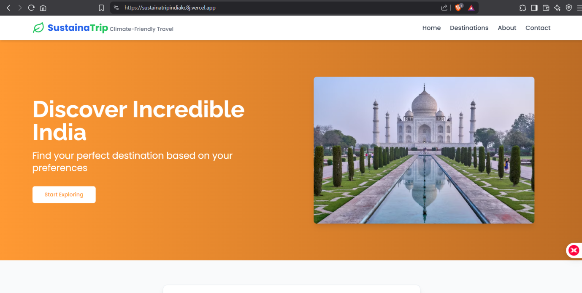

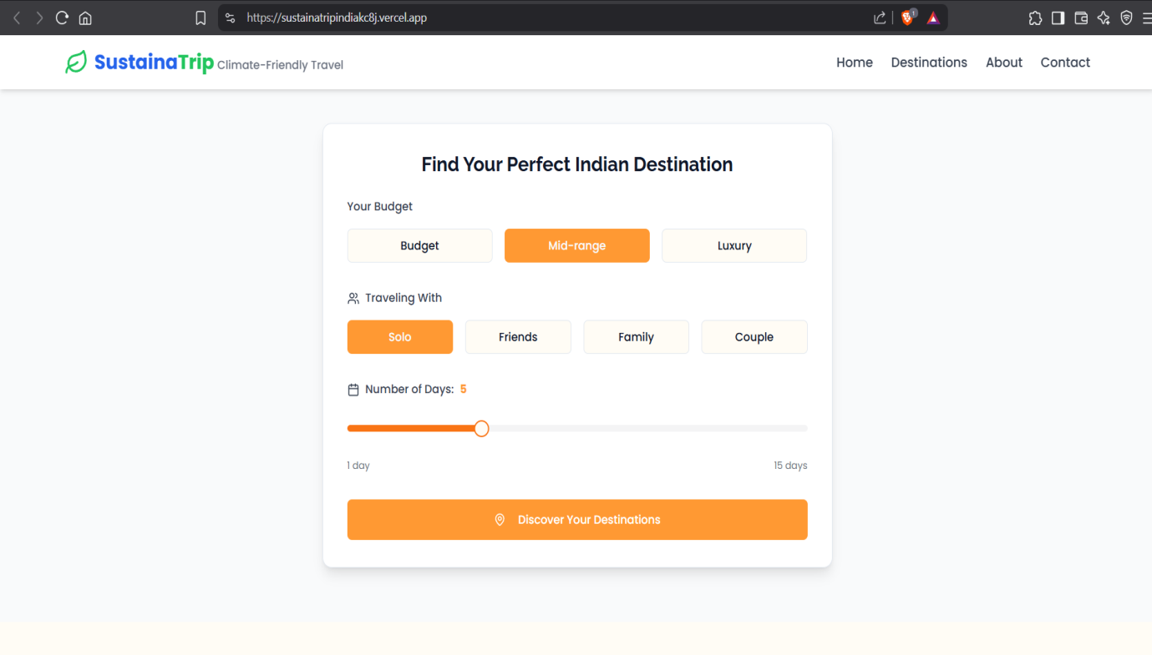

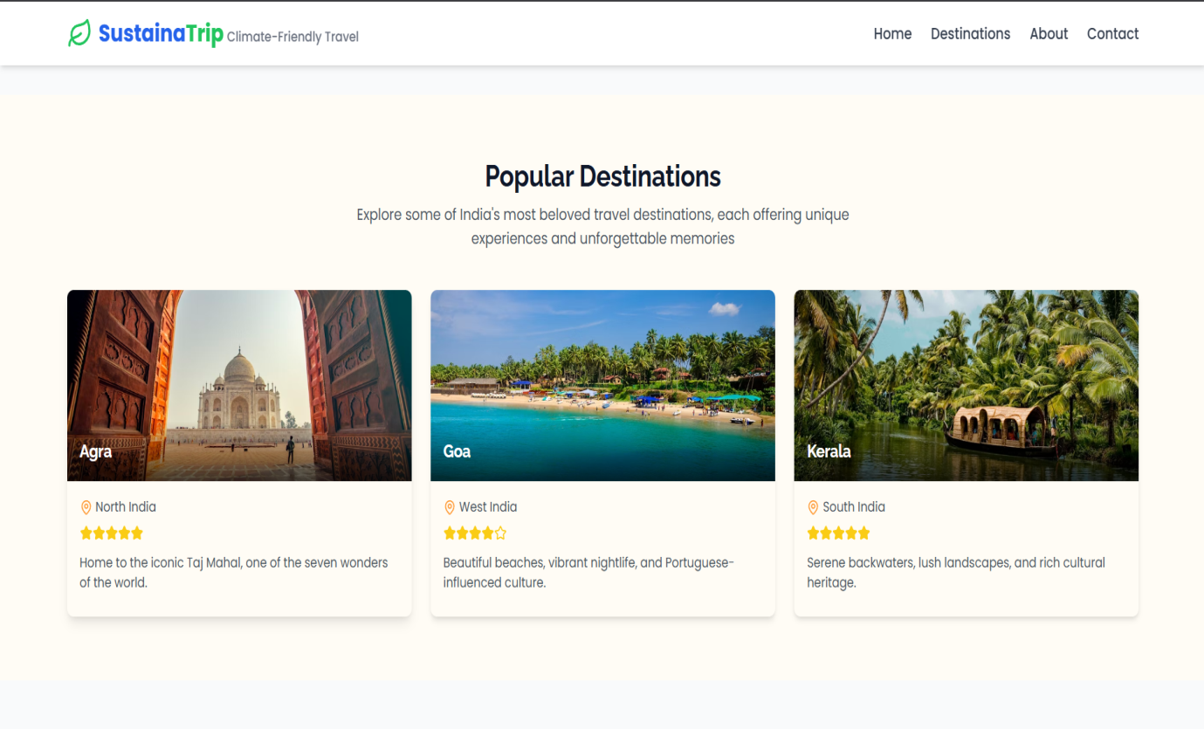

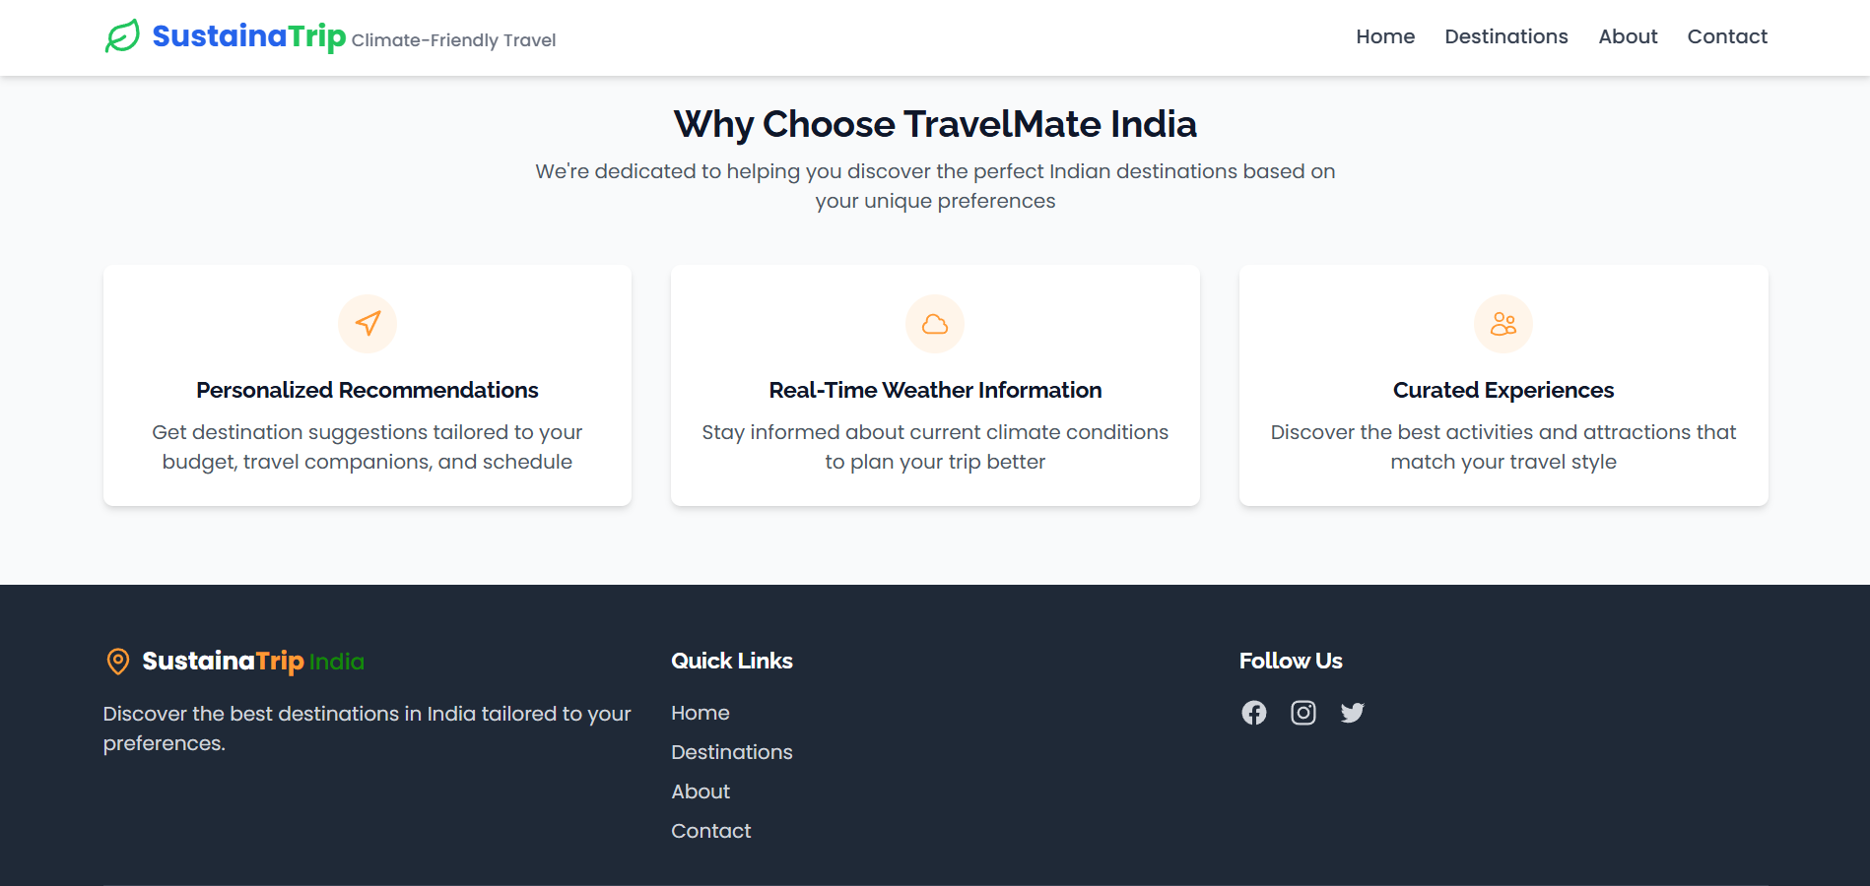

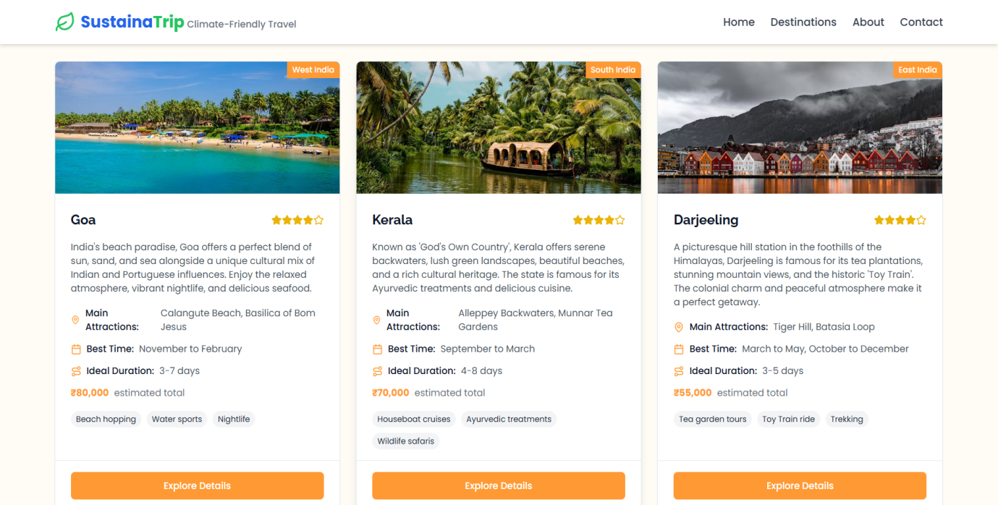

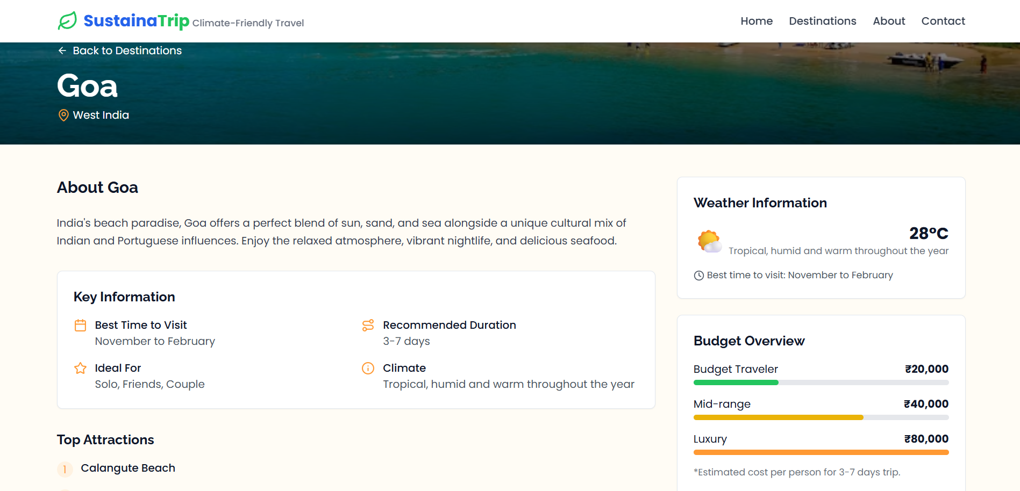

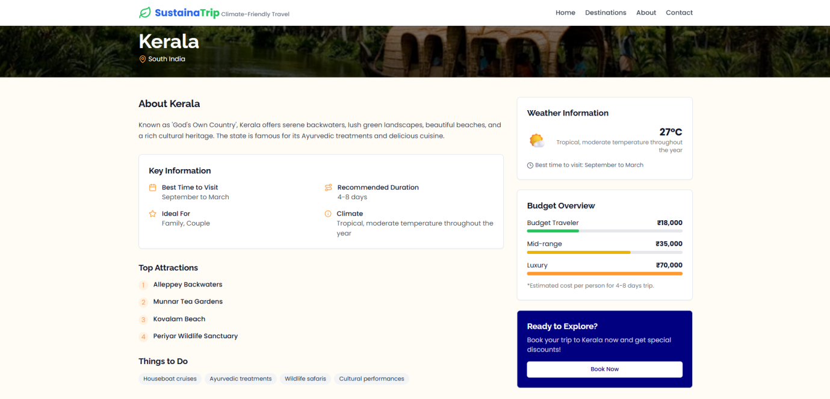

Conclusion and Future Scope
SustainaTrip marks a significant advancement in promoting sustainable travel by providing users with a platform that empowers them to make environmentally-conscious decisions. Through an intuitive interface and data-driven recommendations, the app offers personalized travel itineraries that minimize carbon footprints while maximizing travel experiences. By focusing on sustainable tourism, including eco-friendly transportation options, green accommodations, and carbon offsetting opportunities, SustainaTrip provides users with the necessary tools to plan trips that are both enjoyable and environmentally responsible.
The development journey of SustainaTrip—from initial idea generation and research to design, implementation, testing, and deployment—has created a solid foundation for an impactful tool in the future of sustainable tourism. The app’s robust backend, user-friendly interface, and integration of real-time data make it a valuable asset in the growing field of sustainable travel. With a clear focus on creating an eco-conscious travel experience, SustainaTrip is poised to play a significant role in reducing the environmental impact of tourism while encouraging a broader societal shift toward greener travel practices.
Future Scope
While SustainaTrip already provides a valuable service for eco-conscious travelers, there are several opportunities for future growth and improvement:
- Expansion of Sustainable Travel Options: Future versions of the app could integrate additional eco-friendly travel modes such as electric vehicle rentals, trains, and bicycles. It could also offer more specific suggestions based on the user’s preferences, such as vegan or zero-waste restaurants and activities.
- Enhanced Carbon Offset Integration: The app could develop partnerships with carbon offset providers to offer more personalized and seamless offsetting options, allowing travelers to compensate for their entire trip’s emissions with minimal effort.
- Local Community Engagement: Introducing features that support local sustainable tourism initiatives could empower local businesses and communities. This might include highlighting eco-tourism spots, local conservation efforts, or projects that promote sustainable development in tourist destinations.
- Collaborations with Travel Service Providers: SustainaTrip could collaborate with airlines, hotels, and transportation companies to offer exclusive deals on eco-friendly options, creating an integrated sustainable travel ecosystem. This could also include partnerships with financial institutions to provide users with green travel financing options.
- Advanced Sustainability Metrics and Reporting: Incorporating advanced sustainability metrics—such as the user’s total carbon footprint across trips, or comparisons of different transportation and accommodation choices—could offer travelers deeper insights into their environmental impact and ways to further reduce it.
Through these future enhancements, SustainaTrip has the potential to become a leading platform in the world of sustainable tourism, empowering travelers to make conscious, responsible choices that contribute to a greener planet.

- References

Books:
- Odum, E.P. & Barrett, G.W. (2005). Fundamentals of Ecology (5th Edition). Brooks/Cole.
  - This book provides the ecological foundation necessary to understand how different ecosystems (such as forests, rivers, and wildlife habitats) function—core to planning sustainable and biodiversity-friendly trips.
- Chapin, F.S., Matson, P.A., & Vitousek, P.M. (2011). Principles of Terrestrial Ecosystem Ecology. Springer.
  - Offers in-depth coverage of ecological processes in terrestrial environments, which helps inform eco-tour itinerary planning by understanding species interaction and land use impact.

2. Biodiversity and Ecological Databases (Useful for SustainaTrip):
- Global Biodiversity Information Facility (GBIF)
  - Open-access global biodiversity data platform; can support destination selection and biodiversity hotspot identification in the SustainaTrip system.
- Encyclopedia of Life (EOL)
  - A rich resource for plant and animal species profiles, aiding SustainaTrip in generating educational content and species-specific travel recommendations.
- IUCN Red List of Threatened Species
  - Provides conservation status of species; crucial for avoiding disturbance of endangered habitats and promoting eco-conscious itineraries in the SustainaTrip planner.

